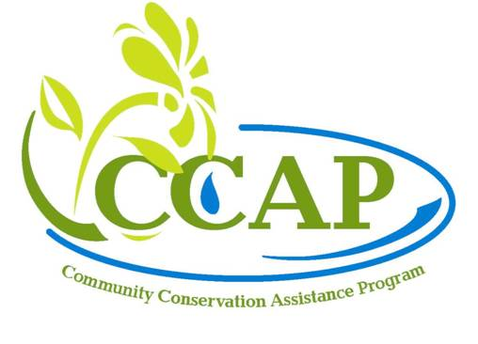Name Soil & Water Conservation District
Address
City, NC Zip
Phone: 555-555-5555

Resource Concern Description and Conservation Plan

Wally Wolfpack
1 Conservation Lane
Clearwater, NC 27000

Parcel #1234567890

Property Type:
Government (County)

General Property Description:
This site is located on a government complex on property of over 100 acres. The focus will be on one of these buildings in a “stand-alone” situation. Considerable open area (turf lawn) is present around this building with some ornamental plantings maintained by the Master Gardeners (Extension Service). County staff provides maintenance on the building as well as the grounds. The Cooperator has offices in this building and has a good working relationship with other county staff located in the same building.

Soils:
Please look at the soils report for additional information (Web Soil Survey report). Generally, there is a mixture of soils on and near the location of the BMP including Alaga loamy sand, Pactolus loamy sand, and Wagram loamy sand in proximity to the work site. The site has been highly disturbed as the building, parking, and other infrastructure was built in immediate proximity of the work to be performed but characteristics still mimic those found in the soil survey. A few borings and the Raingarden soils test confirmed good drainage, possibly excessive drainage. No wet-natured or wetland soils are present.

Description of the Natural Resource Concerns
The Cooperator contacted us about flooding of the area during heavy storm events. Plant bed areas and roof line runoff indicates erosion present. Additionally, the runoff flows into a drop inlet and culvert system that outlets into a ditch that empties into a perennial stream (surface water classification NSW). As the turf grass around the building is fertilized, it was determined that the site would make a good CCAP project, to eliminate erosion and treat excessive nutrient runoff.

Planned Remedies and Potential Alternatives:
The assessment pointed to employing two raingardens to treat the roof water collected from the plant bed areas and the adjoining turf grass lawn areas that empty into the drop inlet and culvert system. The drop inlet will serve as the outlet for the 10-year 5-minute outlet that will capture the necessary flow from the peak flow design needs. Cut material from the construction of the raingardens can be utilized to fill the eroded areas. Cisterns could potentially be installed to capture the roof water, but it was determined that the raingardens will provide more treatment at a lower cost. Regrading the area to alleviate the flooding is not a viable alternative as the entire area has little slope. Regrading would lead to extensive costs and no treatment would be provided.

Potential Issues and Considerations:
Below is a bulleted list of potential issues and considerations:
- Blueprints of the building site including infrastructure such as electrical, gas, water and sewer lines, and other infrastructure must be obtained to determine site constraints
- It is known that a gas line is in close proximity to the work to be performed, special precaution needs to take place regarding
- Gutters are needed in the treatment area; CCAP cannot cost share on the gutter installation but can be used toward meeting the 25% match requirement
- As these will be large gutters, treatment at the outlet will need to be addressed; this can be treated using a rock-lined downspout outlet and/or a forebay to the raingardens
- The raingardens will be in proximity to the buildings. The initial assessment showed the minimum distances can be obtained but care needs to be taken to ensure the setbacks are employed during layout and construction
- Sidewalks are in proximity to the work performed; ensure the sidewalks are not compromised and there is not excessive slope and cut from the sidewalk to the raingardens
- County staff has the equipment and expertise to construct the gardens
- Minimal soil disturbance is suggested
- Hand labor will be necessary after the initial construction of the raingardens for final grades and to maintain the minimal soil disturbance
- There are no issues with ingress/egress or staging of materials, but these areas need to be identified and shown on the plan map
- Extension Service staff with access to the Master Gardeners is highly engaged and willing to perform the plantings and possible hand labor as is the soil and water conservation staff
- Extension staff is well versed in the suitable plant materials for the project and is working with the Soil and Water Conservation District staff on this project
- Soils maps and borings indicate high infiltration of these soils; care should be taken to ensure the proper plant material is used, potentially drought tolerant materials; consult with Extension Service staff or use other guidance materials to determine these plant materials
- Construction may take place out of “normal” planting dates; ensure plant materials can be watered if outside the normal dates
- Discussions have taken place with both the County Facilities staff (general building maintenance) as well as the Grounds Maintenance staff (for landscaping maintenance)
- County staff has been briefed on the maintenance requirements and staff has been instructed on the special requirements for this cost share practices. The grounds at this building have the Master Gardeners maintain this portion of the property, they are well-versed in proper maintenance and will be trained on this as a part of the project
- Invoices and receipts may reflect the costs associated with the construction of the practice and may be used as in-kind or actual cost of construction
- Invoices and receipts may be used as in-kind costs for volunteer hours by the Master Gardeners toward overall project costs
- The gutter installation cannot be cost-shared, however, as it is a necessary part of the proper function of this practice it can be used toward match
- Plant materials may possibly be donated/contributed toward the project; these may be used as in-kind contribution at standard industry rates (verification by up-to-date nursery website costs)
- Training opportunities for soil and water conservation district staff exist on this site
- An opportunity exists for signage regarding the CCAP program and stormwater retrofit treatment
- High visibility site by organization’s clientele

Plan Map:

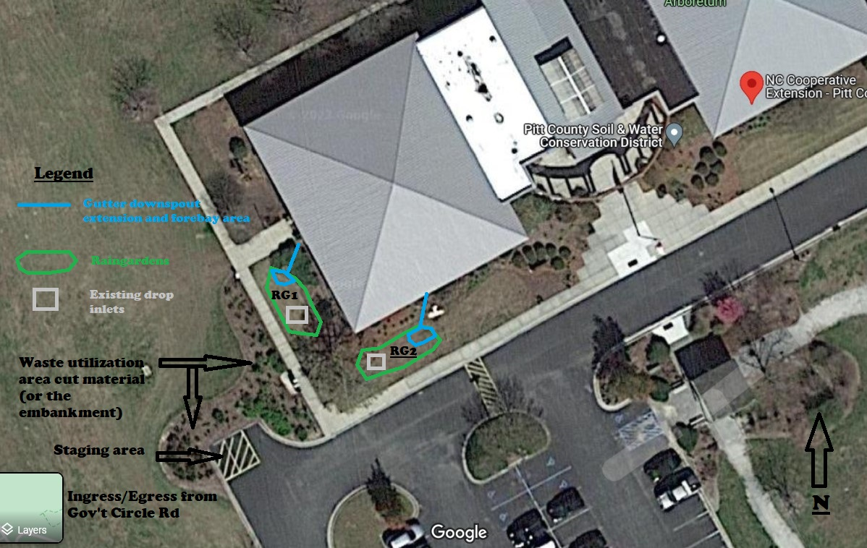

Conservation Plan of Operations

Backyard Raingarden:
Install a Backyard Raingarden according to the design sheet provided and as laid out by the conservationist. The Raingarden will reduce the volume and velocity of impervious surface runoff water, eliminating erosion and providing treatment of nitrogen and phosphorus through the retention and uptake of these nutrients. This practice must conform to the Standards and Specifications as provided. Maintain the raingarden for the term length of the contract by following the Operations and Maintenance form provided.

Backyard Raingarden | Planned Amount (sq ft) | Month | Year | Applied Amount | Date
RG 1 | 120 sq ft | April/May | 2022
RG 2 | 150 sq ft | April/May | 2022
Total | 1,100 sq ft

Attachments
- Backyard Raingarden standards and specifications
- Backyard Raingarden design sheet
- Vegetation information as needed and pertinent
  - New Pollinator Plant list – spreadsheet (will be a link, not included)
  - NC Native Plant Society Plant Search
- Operations and Maintenance form
Other Maps

Site - zoomed out. Note the variances with the historic imagery below. Particularly note the trees to the east and south of the District office.
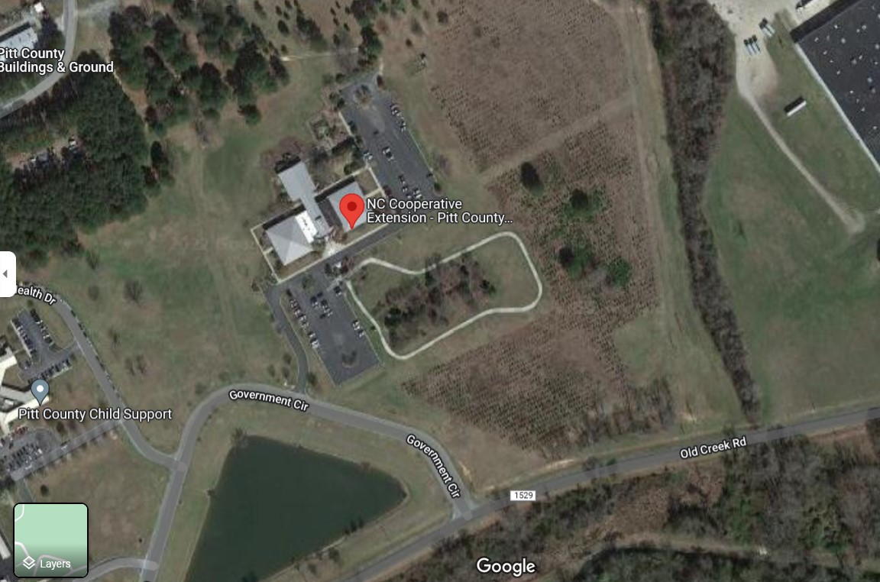

Site - zoomed in
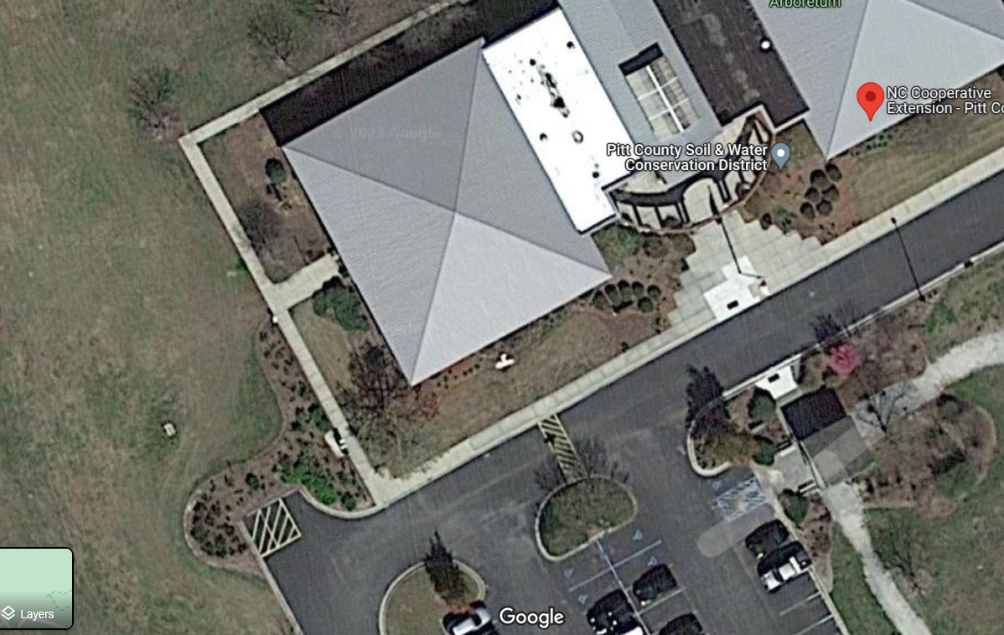
Historic Imagery
1993, 1998, 2015

The 1993 aerial imagery below shows additional site development occurred between 1993 and present day
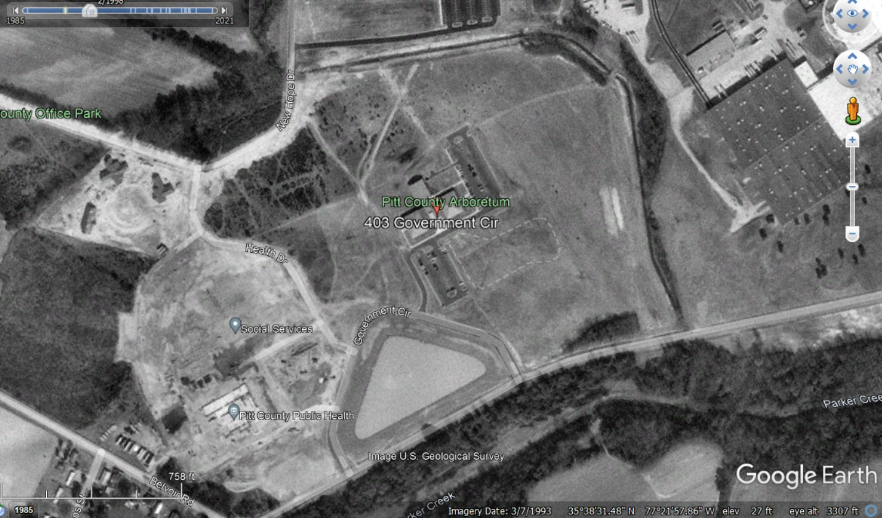

The 1998 imagery below shows the addition of the new buildings to the west of the District Office building. Some additional land to the northwest has been cleared and buildings constructed. The trees in the NW area have matured.
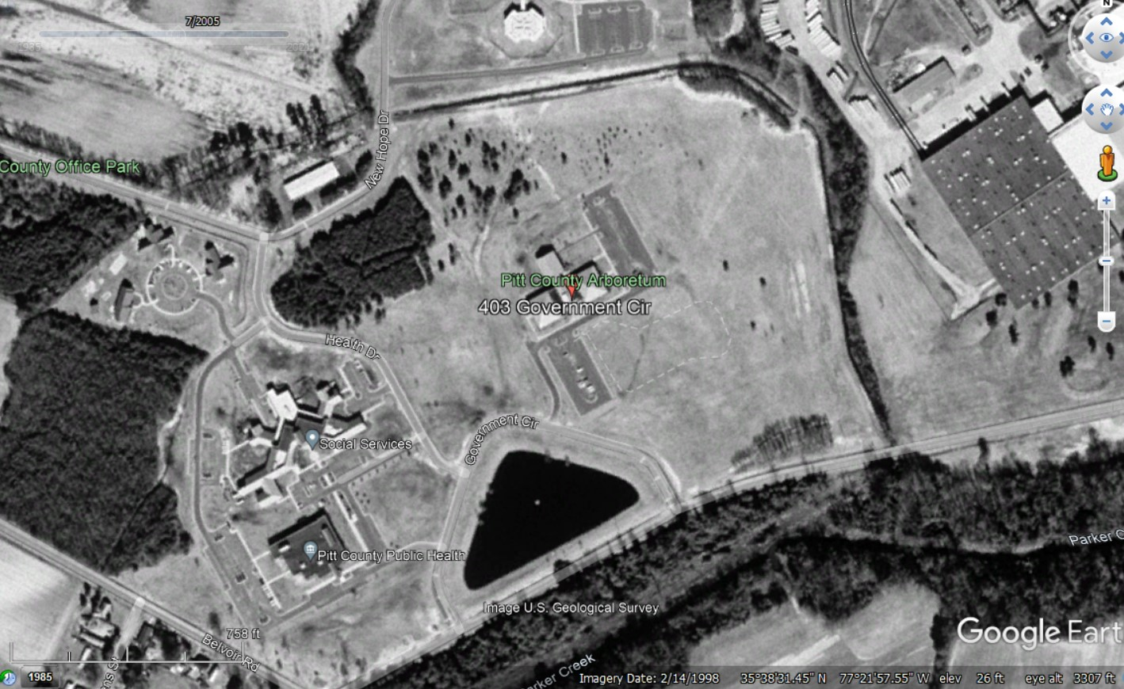
The 2015 color aerial photography shows increased development and some additional trees planted and growing to the east and southeast of the District office with some additional development having taken place in the very northwest corner of the photo.
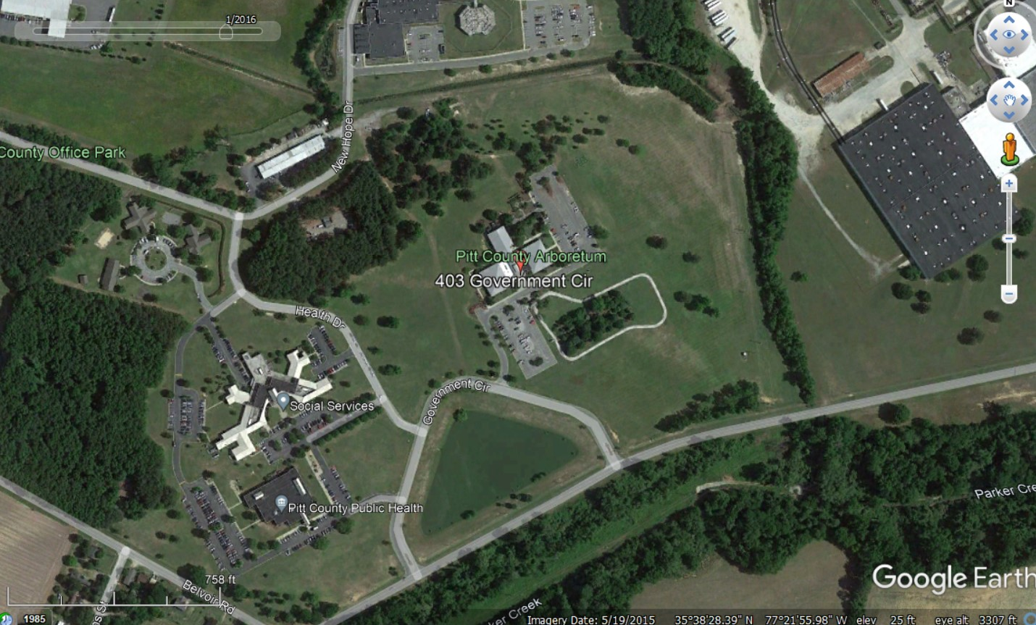

CERTIFICATION OF PARTICIPANTS

_________________ ________
LANDOWNER DATE

CERTIFICATION OF DISTRICT:

Conservation Planner

_________________ ________
NAME DATE


Conservation District

_________________ ________
DISTRICT SWCD DATE

Written Descriptions for Copying and Pasting

Abandoned Well Closure:
Seal and permanently close the abandoned well in accordance with the Certified Well Contractor standards. The closure must have the GW-30 Well Abandonment Record completed in accordance with the regulatory authority’s process. The permanent closure of the well will prevent contaminated surface waters, debris, and other potential sources of pollution from entering shallow groundwater. Additional benefits include eliminating hazards to humans, machinery, and animals.

Backyard Raingarden:
Install a Backyard Raingarden according to the design sheet provided and as laid out by the conservationist. The Raingarden will reduce the volume and velocity of impervious surface runoff water, eliminating erosion and providing treatment of nitrogen and phosphorus through the retention and uptake of these nutrients. Native plant species are recommended where appropriate but not required. This practice must conform to the Standards and Specifications as provided. Maintain the raingarden for a minimum of the term length of the contract by following the Operations and Maintenance form provided.

Backyard Wetland:
Install a Backyard Wetland according to the design sheet provided and as laid out by the conservationist. The Wetland will reduce the volume and velocity of impervious surface runoff water, eliminating erosion and providing treatment of nitrogen and phosphorus through the retention and uptake of these nutrients. Native plant species are recommended where appropriate but not required. This practice must conform to the Standards and Specifications as provided. Maintain the raingarden for the term length of the contract for a minimum of the length of the contract period by following the Operations and Maintenance form provided.

Bioretention Area:
Install a Bioretention Area according to the design provided and as laid out by the conservationist. The Bioretention Area will reduce the volume and velocity of impervious surface runoff water, eliminating erosion and providing treatment of nitrogen and phosphorus through the retention and uptake of these nutrients. Native plant species are recommended where appropriate but not required. This practice must conform to the Standards and Specifications as provided. Ensure the watershed area draining to the Bioretention Area is stable or install any necessary practices needed to reduce sediment from taking up the treatment volume. If soil media is used, ensure the P-index is 40 or below, particularly in nutrient sensitive watersheds. Maintain the Bioretention Area for a minimum of the length of the contract period.

Cistern:
Install a Cistern according to the design provided and as laid out by the conservationist. The cistern will capture roof runoff preventing erosion and nutrient loading into nearby watercourses. The water is to be utilized appropriately and as outlined in the water usage demand tool. Adjustments should be made to the water usage plan as utilization conditions change. This practice must conform to the Standards and Specifications as provided. Adhere to the maintenance plan that has been provided.

Critical Area Planting:
Install the Critical Area Planting according to the design provided and as laid out by the conservationist. The Critical Area Planting will eliminate erosion and associated attached nutrients to our watercourses, providing permanent vegetative cover. Native plant species are recommended where appropriate but not required. This practice must conform to the Standards and Specifications as provided. Maintain the Critical Area Planting for a minimum of the length of the contract period and as outlined in the Critical Area Planting Operations and Maintenance form.

Diversion:
Install a Diversion according to the design provided and as laid out by the conservationist. The Diversion will eliminate erosion and associated attached nutrients by grading a channel to the dimensions required in the design and planting appropriate vegetation and/or using Turf-Reinforced Matting (TRM) or other velocity reduction materials as needed to reduce the velocities to non-erosive levels. The Diversion may be used in conjunction with other BMPs or as a “stand alone” project. Perform supporting work such as landsmoothing, grading gully or deep-rill eroded areas, or similar work as needed. This practice must conform to the Standards and Specifications as provided. Maintain the Diversion for a minimum of the length of the contract period.

Grassed Swale:
Install a Grassed Swale according to the design provided and as laid out by the conservationist. The Grassed Swale will eliminate gully or deep rill erosion by grading the eroded area to the dimensions required in the design and planting appropriate vegetation and/or using Turf-Reinforced Matting (TRM) or other velocity reduction materials as needed to reduce the velocities to non-erosive levels. Should additional treatment of the watershed draining into the Grassed Swale be necessary for proper function, any of these eroded areas must be addressed as a part of the installation of the swale. Consideration should be given to the proper vegetation based on soil conditions, velocities of the design, and short and long-term maintenance of the practice. This practice must conform to the Standards and Specifications as provided. Maintain the Grassed Swale for a minimum of the length of the contract period.

Impervious Surface Conversion:
Install an Impervious Surface Conversion according to the design provided and as laid out by the conservationist. The Impervious Surface Conversion will reduce the volume and velocity of impervious surface runoff water, eliminating erosion and providing treatment of nitrogen and phosphorus through the retention and uptake of these nutrients through the establishment of plant materials where the impervious surfaces were. Native plant species are recommended where appropriate but not required. Extreme care should be taken west of I-95 to ensure there is appropriate treatment of the underlying soils so appropriate infiltration can be realized by implementing this practice. This practice must conform to the Standards and Specifications as provided. Maintain the Impervious Surface Conversion for a minimum of the length of the contract period.

Marsh Sill:
Install a Marsh Sill in accordance with the CAMA permit. The Marsh Sill will eliminate shoreline erosion and provide protection from wave energy. Additional potential benefits to be realized include soil and/or vegetation accretion on the landward side of the sill and increased marsh flora and fauna habitat. This practice must conform to the Standards and Specifications as provided. Maintain the Diversion for a minimum of the length of the contract period.

Permeable Pavement:
Install Permeable Pavement according to the design provided and as laid out by the conservationist. The Permeable Pavement will reduce the volume and velocity of impervious surface runoff water, eliminating erosion and providing treatment of nitrogen and phosphorus through the retention of stormwater. Extreme care should be taken west of I-95 to ensure there is appropriate treatment of the area so appropriate infiltration can be realized by implementing this practice. This practice must conform to the Standards and Specifications as provided and in accordance with the manufacturer’s Standards and Specifications. Maintain the Permeable Pavement for a minimum of the length of the contract period.

Pet Waste Receptacle:
Install Pet Waste Receptacles in accordance with the manufacturer’s Standards and Specifications. The Pet Waste Receptacles should be placed in strategic locations where accessibility and trafficking areas are most prevalent. The installation of the Receptacles will result in reducing animal waste into our watercourses, reducing e. coli, enterococcus, and other harmful bacteria and nutrients into our water courses. Consideration should be given to vandalism. Consideration must be given to maintaining a supply of bags and for routine sanitary disposal of the waste material generated. Maintain the Pet Waste Receptacles for a minimum of the length of the contract period.

Riparian Buffer:
Install the Riparian Buffer according to the design provided and as laid out by the conservationist. The Riparian Buffer will eliminate erosion and associated attached nutrients to our watercourses, providing uptake by the permanent vegetative cover. Native plant species must be planted. This practice must conform to the Standards and Specifications as provided. Maintain the Riparian Buffer for a minimum of the length of the contract.

Stormwater Wetland:
Install a Stormwater Wetland according to the design provided and as laid out by the conservationist. The Stormwater Wetland will reduce the volume and velocity of impervious surface runoff water in the watershed, eliminating erosion and providing treatment of nitrogen and phosphorus through the retention and uptake of these nutrients. Native plant species are recommended where appropriate but not required. This practice must conform to the Standards and Specifications as provided. Ensure the watershed area draining to the Stormwater Wetland is stable or install any necessary practices needed to reduce sediment from taking up the treatment volume. Maintain the Stormwater Wetland for a minimum of the length of the contract period.

Stream Restoration:
Install a Stormwater Wetland according to the design provided and as laid out by the conservationist. The Stormwater Wetland will reduce the volume and velocity of impervious surface runoff water in the watershed, eliminating erosion and providing treatment of nitrogen and phosphorus through the retention and uptake of these nutrients. Native plant species are recommended where appropriate but not required. This practice must conform to the Standards and Specifications as provided. Ensure the watershed area draining to the Stormwater Wetland is stable or install any necessary practices needed to reduce sediment from taking up the treatment volume. Maintain the Stormwater Wetland for a minimum of the length of the contract period.

