Step by Step Guide to Submit a CCAP Application
Note: As you progress through the application answers are saved automatically in the browser. You can resume the application in the same browser at a later time.
Step 1. Navigate to https://arcg.is/15b1942
Step 2. You will come to the homepage of the survey. Click “Next”
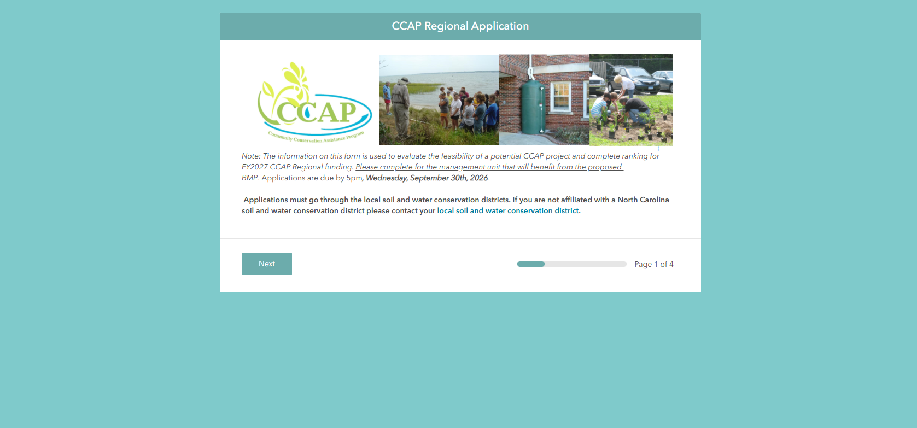
Step 3. Fill in Q1-Q5 until you get to the map.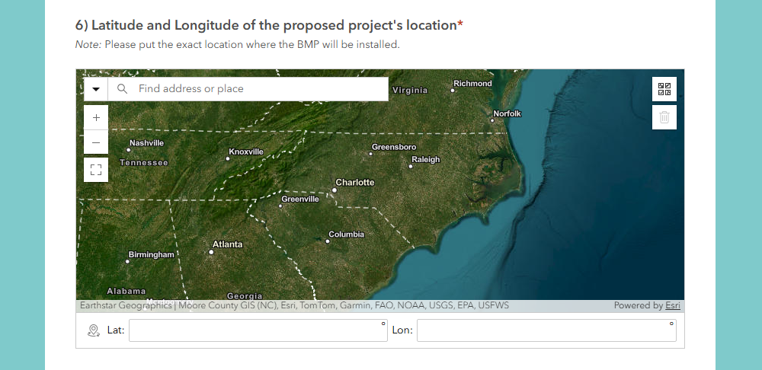

Step 4. On Q6, enter the address of the proposed project’s location where the BMP(s) will be installed. You can also zoom in on the map and place a point that way. Place a point on the map. The Latitude and Longitude will automatically fill in.
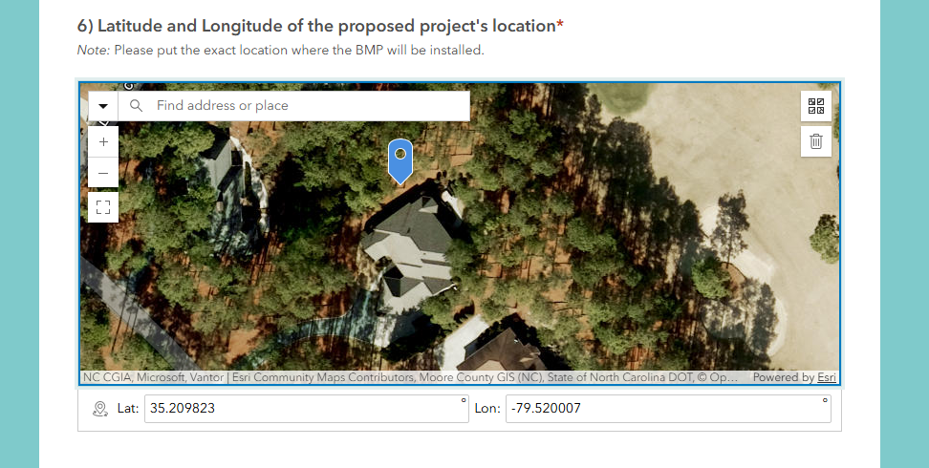
Step 5. Q7: Fill in the water quality benefits for the proposed BMP(s). Please attempt these calculations yourself before choosing “Please calculate for me”. User guides are provided for each tool. If you do the calculations, upload the spreadsheet you used in Q8.
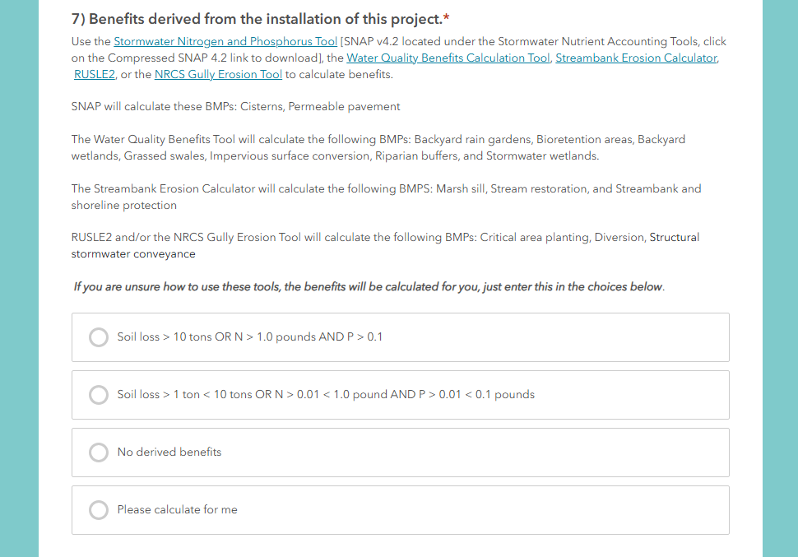

Step 6. Q9-18: These questions are used as part of the Regional Application Ranking Parameters for the application. Note: If you are applying for other funds they must be secured to receive additional points.
Step 7. Q14-18: Once you reach Q14 you will notice that from here to Q18 have been automatically filled in. There are background map calculations running based on the initial mapping point you provided to fill in these answers. Do NOT change the answer to these questions.
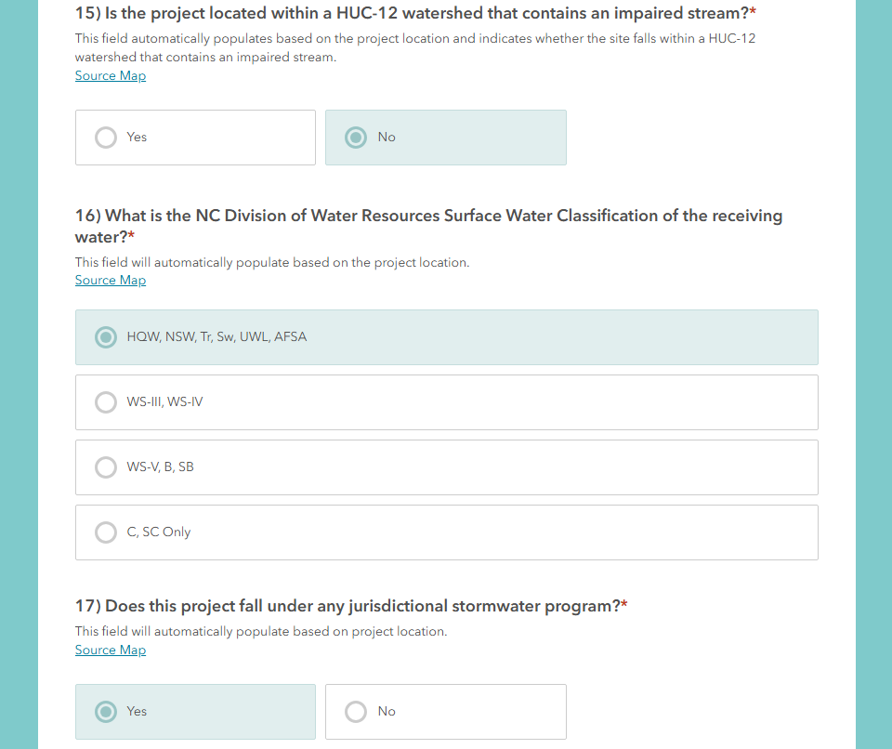
Step 7. Q19-36: Go to the next page. Fill in all Feasibility questions.
Step 8. Q37-40: Go to the next page. Fill in the Funding Request and Additional Project Information questions.
Step 9. Q41-42: Upload a clear image of the site that demonstrates the water quality problem. If you need to upload more than one photo, put your photos in a Word Document or PDF.
Step 10. Q43: Upload any additional files or information. Submit your application! 😊

