
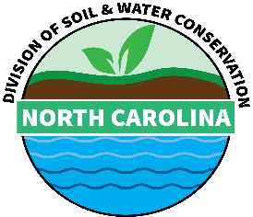
Agriculture Cost Share Program
Stream Protection Well Checklist

ACSP Contract Number: | Technical Representative:
Cooperator Name: | Date:

Please note that ALL documents must be uploaded for contract approval and for payment approval. These will be pended otherwise.
Required Documents for Contracting to upload into CS2:
- NC-ACSP-11 Form (with signature page)
- Map with BMP location, fields and roads
- Wells for Livestock Watering Site Evaluation Sheet
- Cooperator Acknowledgment Form

Required Documents for RFPs to upload into CS2:
- Well Construction Form (GW1)
- Well Check Out Sheet
- Itemized Pump Receipts
- Permit Receipt (if applicable)
- Receipt Summary Form (for actual costs related to the pump ONLY)

Required Well Documents for Contracting Folders (NOT uploaded to CS2):
- O&M Plans (Water Well/Pumping Plant)
- Conservation Plan
- Job Sheets
- Well Diagram
- NRCS CRR Documentation
- Well Permits (if applicable)
- Field Notes
- All items uploaded to CS2 should also be included in the folder

