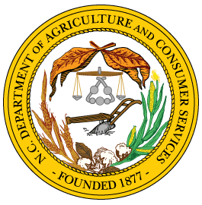
Steve Troxler  Commissioner | North Carolina  Department of Agriculture  & Consumer Services  Division of Marketing | Joe Sanderson  Director

Registration Form for Fruit and Vegetable Handlers Act

Business Name:__________________________________ Contact Person:_________________________
Contact email:__________________________________ Phone number:__________________________
Physical address of business:______________________________________________________________
City:________________________________ State: __________________ Zip:______________________
Mailing Address of business:______________________________________________________________
City:________________________________ State:__________________ Zip:_______________________
Fruits and Vegetables handled in North Carolina
(Check all that apply)

FRUIT
- Apples
- Blackberries
- Blueberries
- Cantaloupes
- Figs
- Grapes
- Melons
- Muscadine Grapes
- Nectarines
- Peaches
- Pears
- Persimmons
- Plums
- Raspberries
- Strawberry
- Tomatoes
- Watermelons

- All ⎕Other___________________

VEGETABLES

- Artichokes
- Asparagus
- Beets
- Bokchoy
- Broccoli
- Butterbeans
- Cabbage
- Carrots
- Celery
- Collards
- Cucumbers
- Edamame
- Eggplant
- Garlic
- Green Onions
- Green Peas
- Greens
- Kale
- Leeks
- Lettuce
- Lima Beans
- Mushrooms
- Mustard Greens
- Okra
- Onions
- Peanuts
- Peppers
- Potatoes
- Pumpkins
- Radishes
- Rhubarb
- Snap Beans
- Snow Peas
- Spinach
- Squash
- Sweet Corn
- Sweet Potatoes
- Swiss Chard
- Turnips
- Zucchini

- Herbs

- All ⎕Other___________________

The annual volume of fruits and vegetables handled in North Carolina $_________________

Date Submitted:______________________ By: ______________________________________________

