ShoWorks Nomination User Guide
To Begin: Go to website: Welcome to ShoWorks! (fairwire.com)
Click Sign In

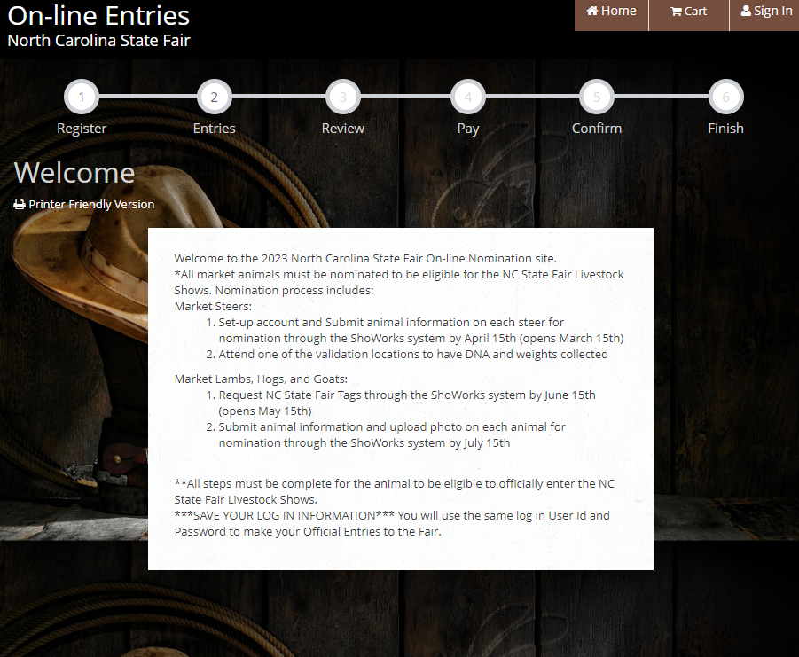

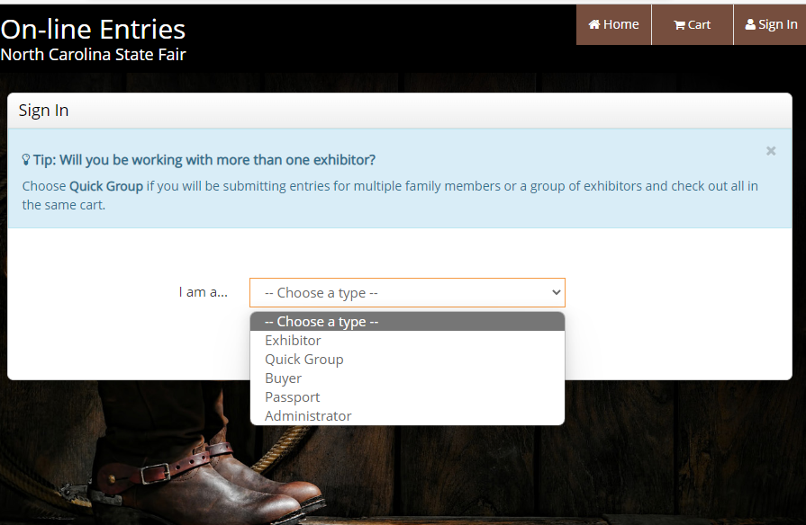

Choose type of Exhibitor you will be entering

Types of Exhibitor
- Exhibitor – will have to create a new account every year
- Passport – RECOMMENDED; account information will be stored for years, and you can look back and see previous years awards, animal information will be stored, can use to register for other fairs

Exhibitor…
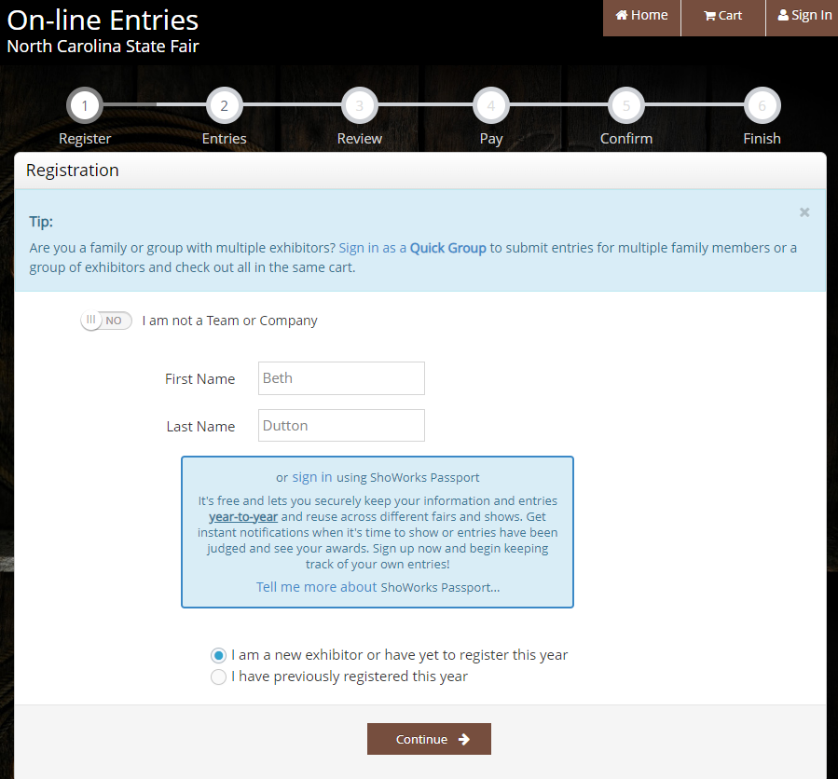
Enter information
First time user or signing in to make edits to previous entries
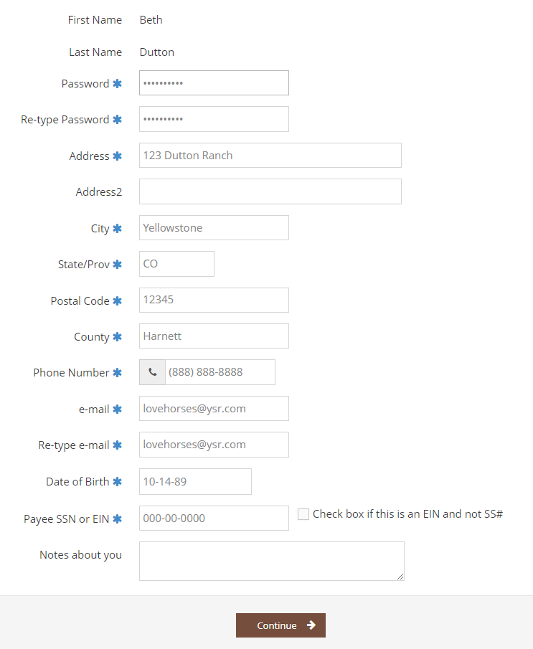
Complete all REQUIRED information

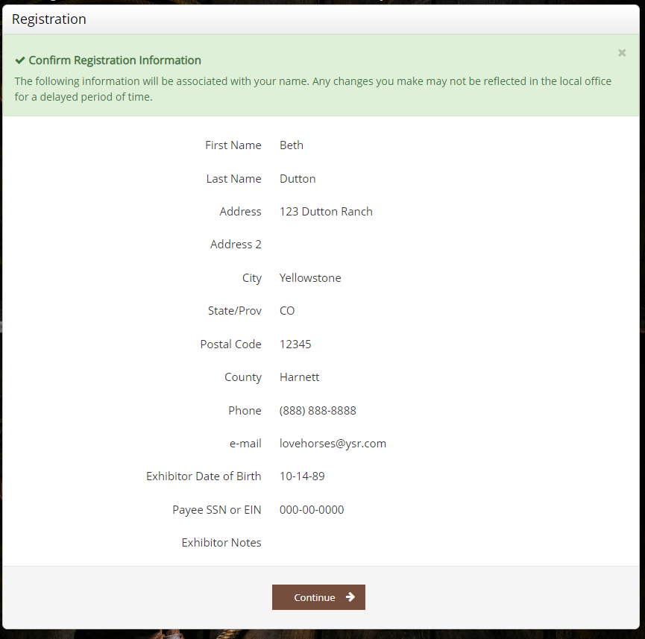

Adding Animal Nominations….

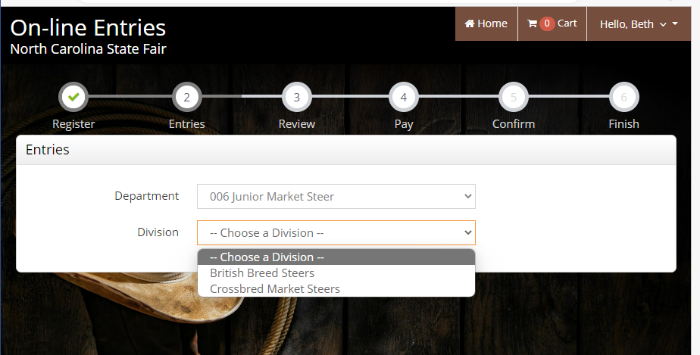

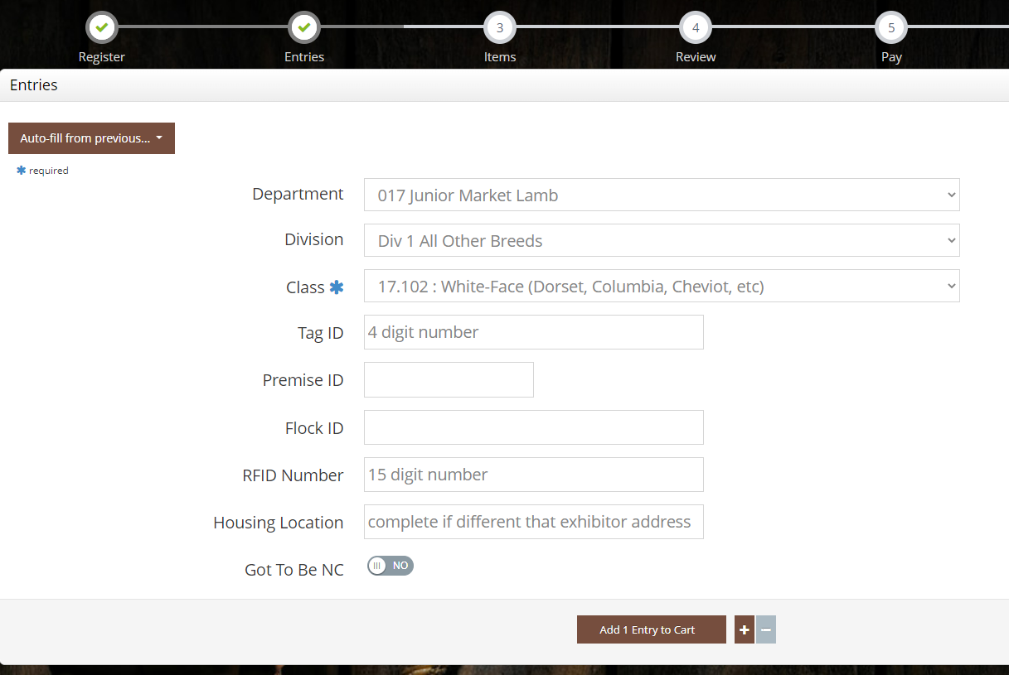

Add 1 Entry to Cart
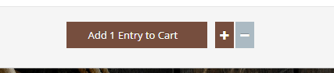

You may add more Entries or click Continue
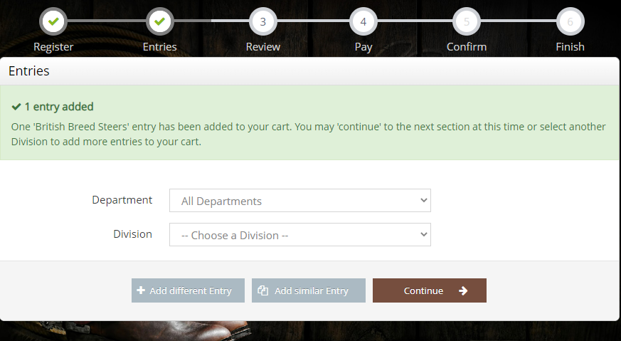

You may now Edit or remove an item, or Check out.
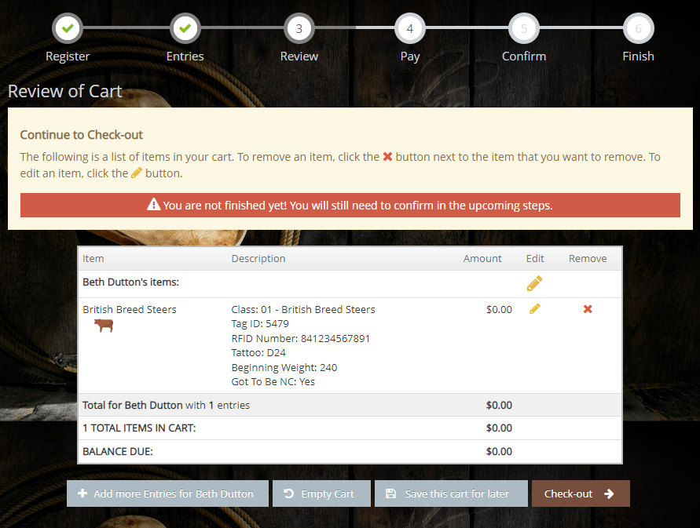

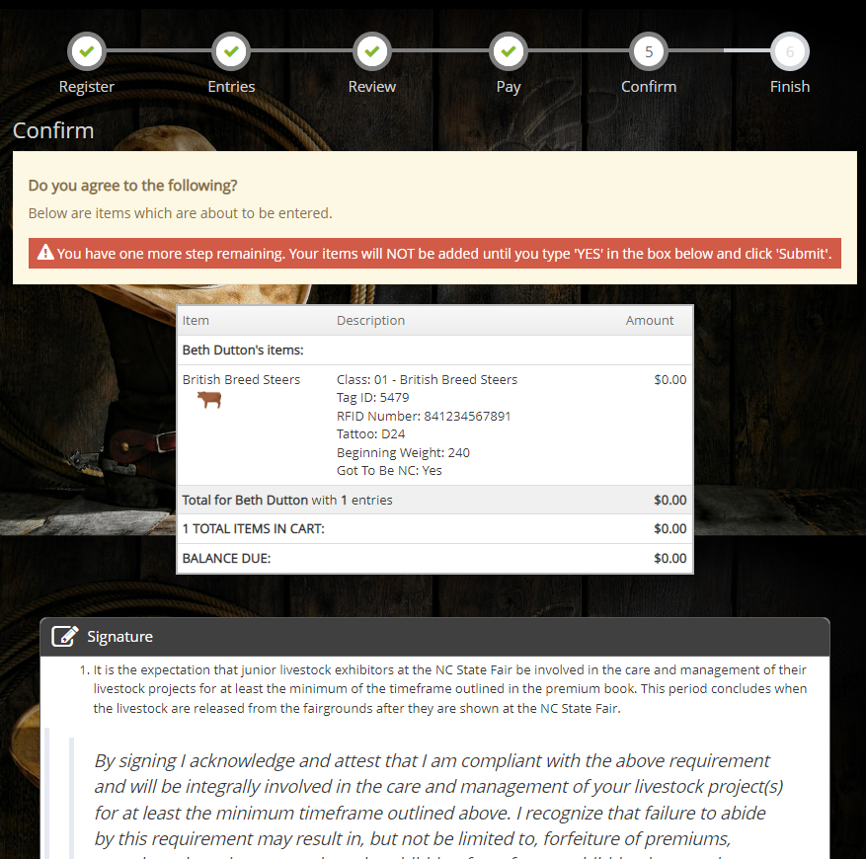
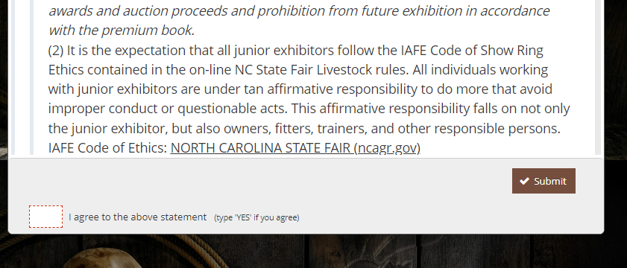
2 – Click Submit
1 – Type YES if you agree

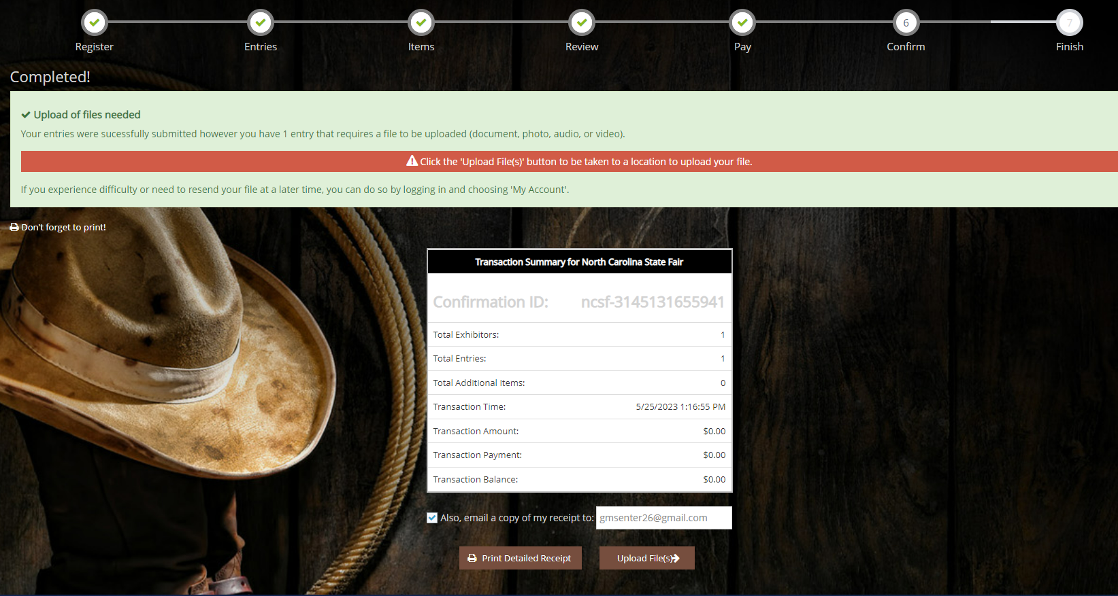
Click Upload Files

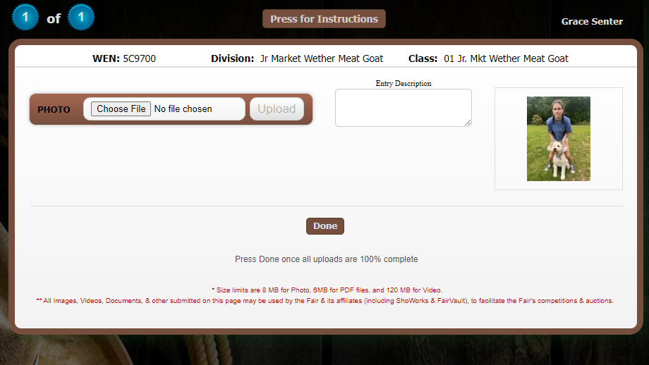
Choose File and Done

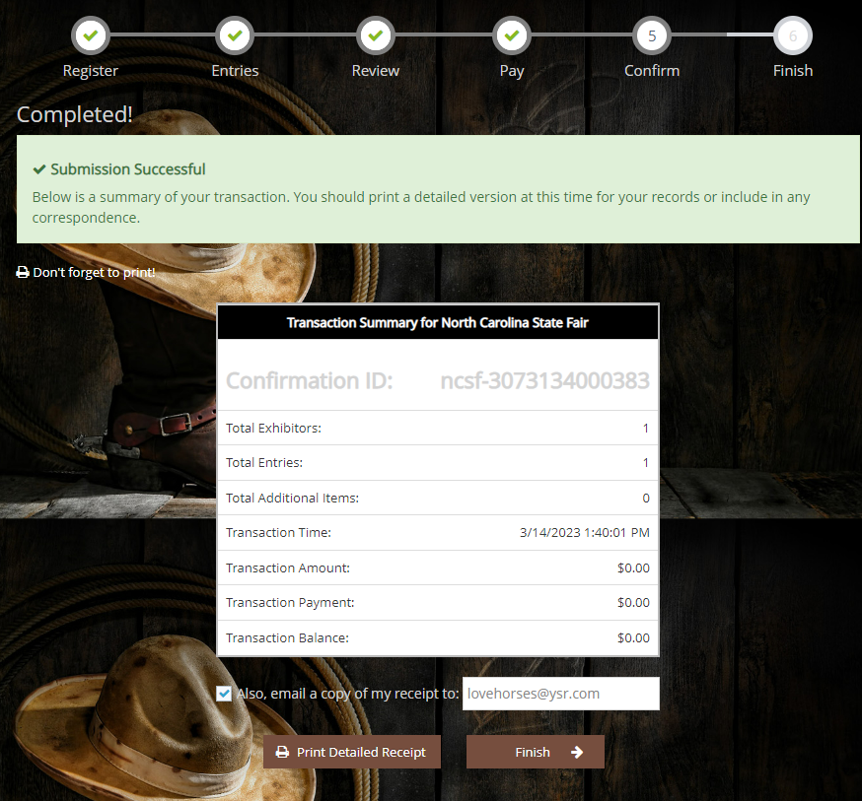

Finish

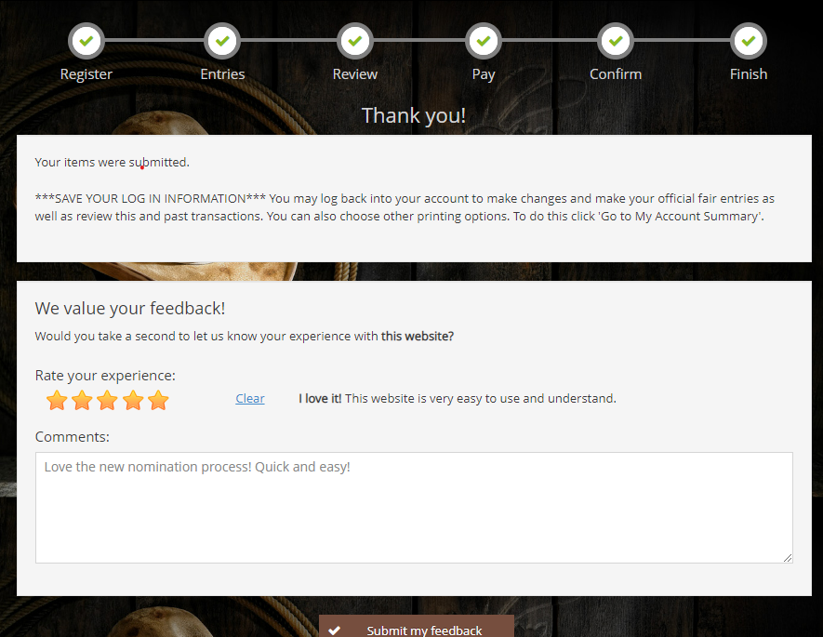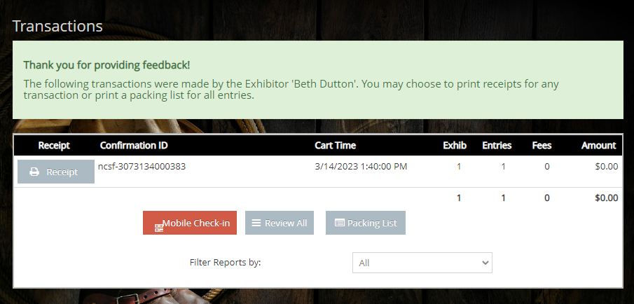
Print Receipt
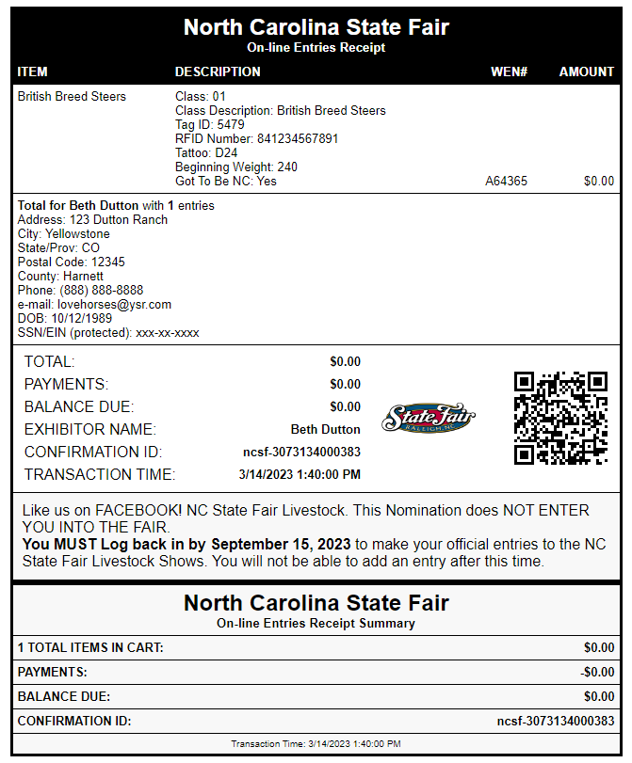

If you need to log back in and upload your photo…..
Log In and Click on the “Hello, (name)” tab; choose Your Past Transactions from dropdown.

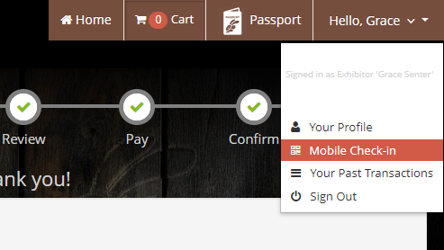

Click Upload Files
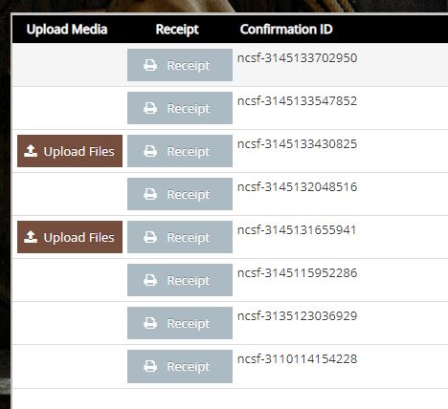

How to Log In as a Passport Account

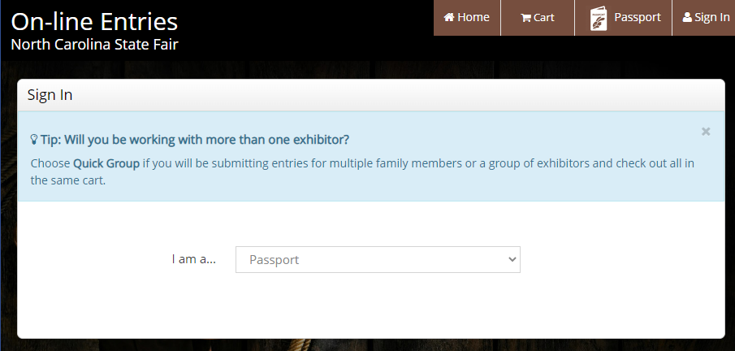
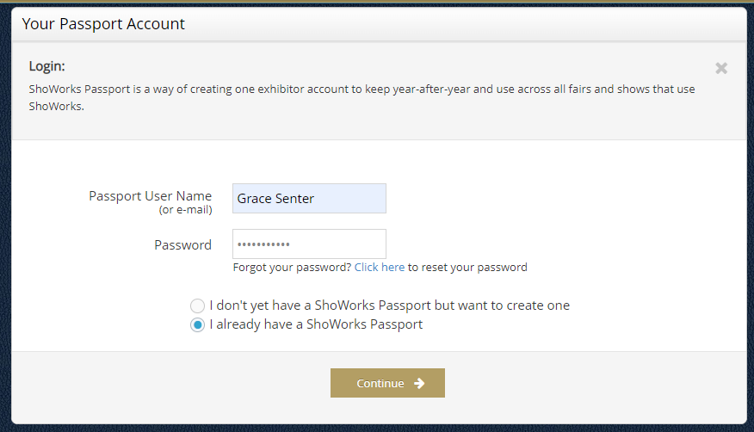
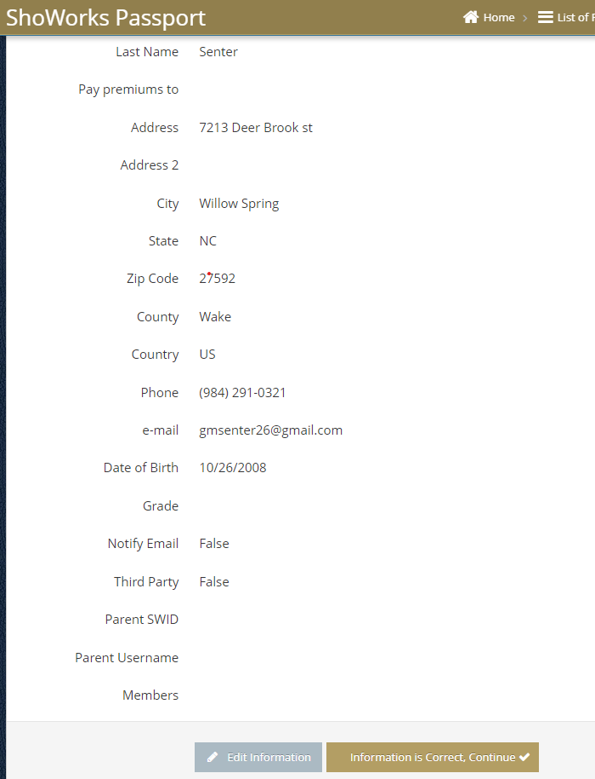
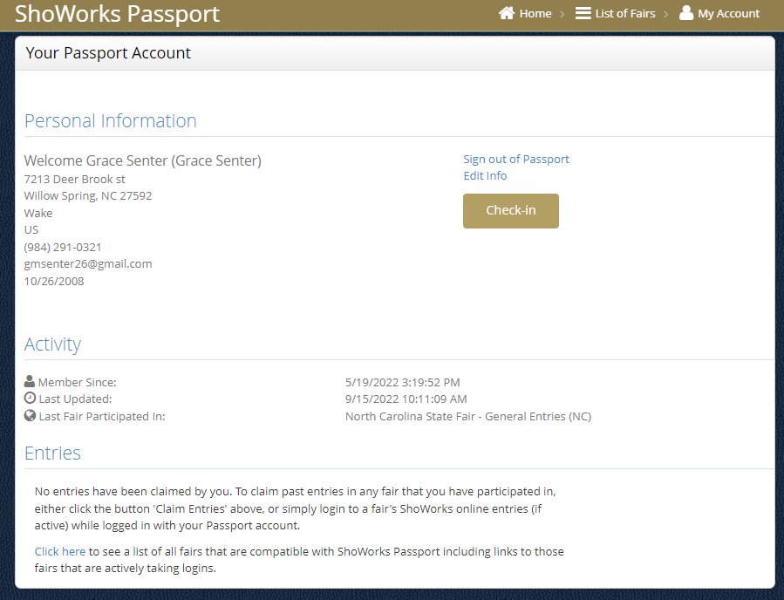

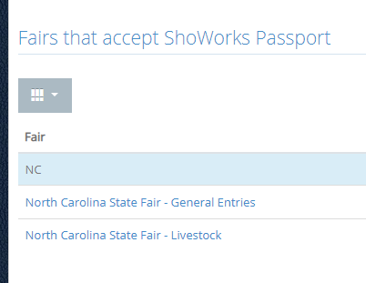

Select the fair you need to enter, and that will take you to the Entry step!

