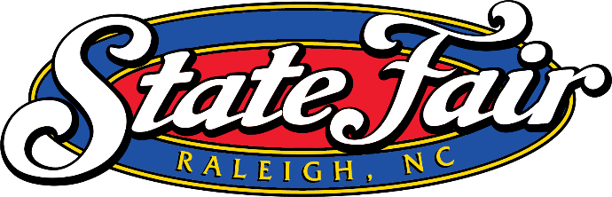
North Carolina State Fair Livestock FFA & 4-H Group Form
Animal possession deadline for 2025 - July 15, 2025, for registered/purebred beef, sheep and swine.

This form must be completed by both the farm/owner of the animal and the FFA Chapter/4-H Club who will be exhibiting the animal and uploaded with a copy of the animal(s) original registration paper(s) by September 15. If animals are from multiple owners, complete a form for each owner.
Farm/Owner’s Name:
Location where the animal(s) will be housed:

Street Address City State Zip code
FFA Chapter/4-H Club_______________________________________________
Advisor/Club Leader Name________________________________________
Animal(s) Information: page 2 for additional animals, if needed.
Animal’s Name | Species | Breed | Animal Birthdate  (Month/Day/Year) | Official Ear Tag or Tattoo | Registration Number

Acknowledgements:
- This Arrangement will remain in force until November 1 of the current year or until terminated by either party.
- We understand that this arrangement is between the youth exhibitor and the owner of the animal.
- Ownership of the animal(s) remains with the Farm/Owner. The title of ownership as stated on the registration certificate of the animal(s) will remain in the possession of the Farm/Owner.
- The animal(s) will NOT be exhibited or used by any other individual(s)/farm during the terms of this agreement.

Advisor/Club Leader Signature________________________________________ Date:_____________________
Farm/Owner’s Signature: Date:

Animal’s Name | Species | Breed | Animal Birthdate  (Month/Day/Year) | Official Ear Tag or Tattoo | Registration Number  (if registered)

