**North Carolina Department of Agriculture**

**and Consumer Services**

**Emergency Programs Division**



**COMPANION ANIMAL SHELTERING TRAILER (CAST)**

**Operations Manual**

**2025**

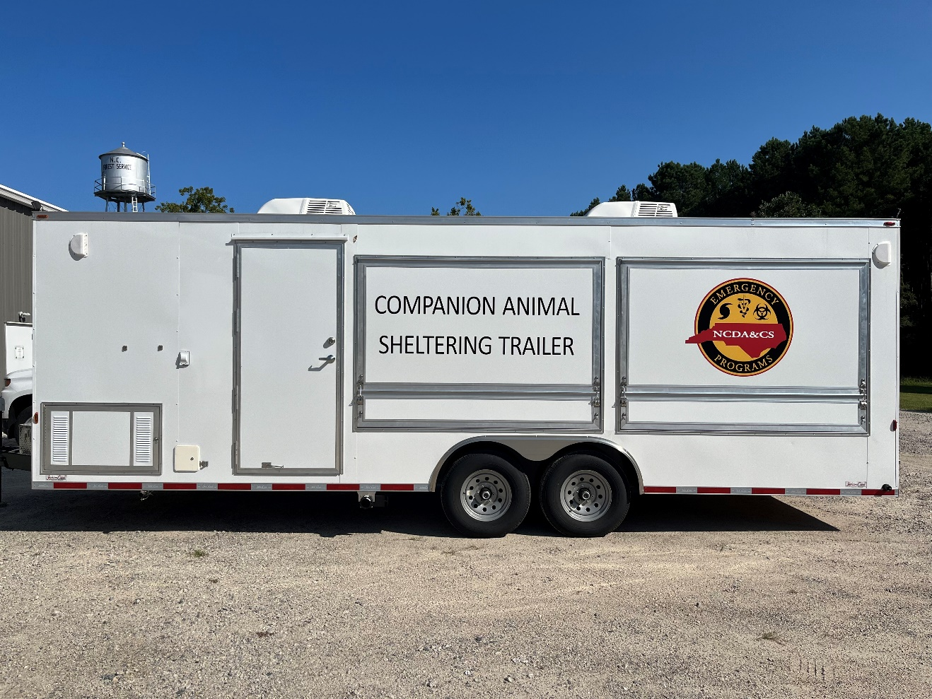

**Table of Contents Page**

Trailer Specifications 3

Fire Extinguisher Location 3

Vehicle Requirements 3

Electric Jack 3

Parking 3

Side Door Steps 4

Fresh Water Tank 4

Fuel Tank 5

Generator 5

Hardwire 6

Breaker panel 6

Lights 6

Water Heater 6

HVAC 7

Wastewater Tank 7

Cleaning inside with the hose 8

Back ramp door 8

Side awning doors 9

**Trailer specifications**

* Estimated weight: 12,000 lbs.
* 8 ft wide x 24 ft long x 7 ft interior height
* 41 total cages
* 23 upper cages – 12 cat portal dividers
* 18 lower cages – 8 removable dividers (store in built-in containers near the back ramp)

**Fire extinguisher location** – store in sink for transport; place next to side door during sheltering

**Vehicle requirements**

* F-250 or above/equivalent
* 2 5/16-inch ball, bumper-pull
* Vehicle will need an electronic brake controller

**Electric jack**

* The jack can be operated manually as well; there is a metal attachment for this in the battery container on the front of the trailer.

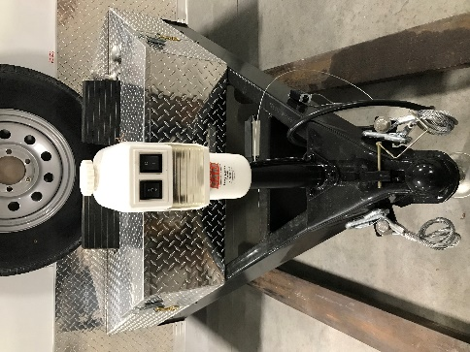

Battery container

**Parking**

* Area needed for operations – 25 ft wide x 45 ft long x 12 ft high
* Park the CAST on as level, hard, well-drained ground as is possible.
* Consider electrical connection for trailer. Ideally connect to hardwire within 24 hours if possible.
* Level trailer side-to-side, then front to back (*level location*)
* Once unit is level, wheels need to be chocked (*chocks location)*
* Once wheels are chocked, place corner stabilizer jacks (corner jacks are NOT to be used to lift the trailer, they are just meant to secure it). (*location*)

**Side door steps**

* Trailer must be level to use steps – otherwise they will not lie flush with the threshold and the side door will not close completely
* Rotate yellow handle to left or right and carefully ease steps down to the ground.

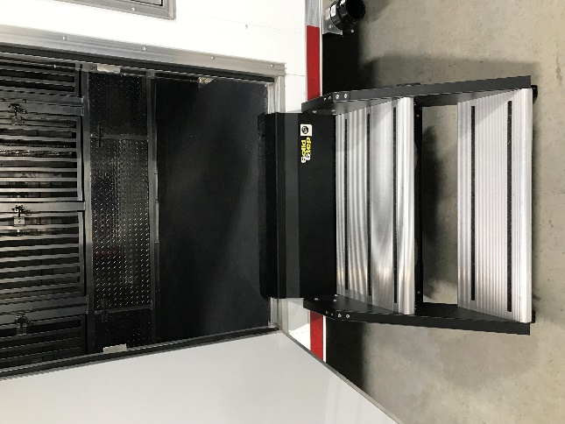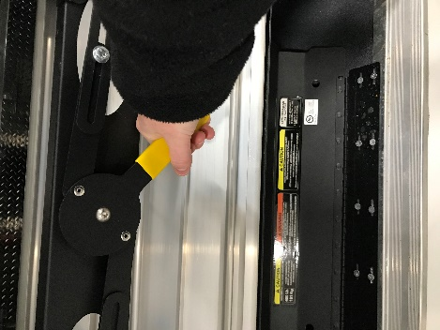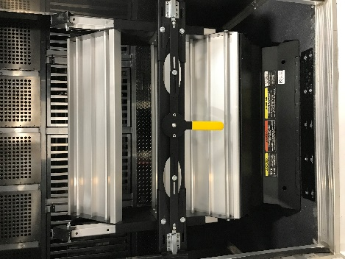

**Fresh water tank** – fill on-site or close to destination

* 30-gallon capacity
* Key needed to open
* Use potable water
* Fill is located on curbside front of trailer
* Fill until it is about to run out the top

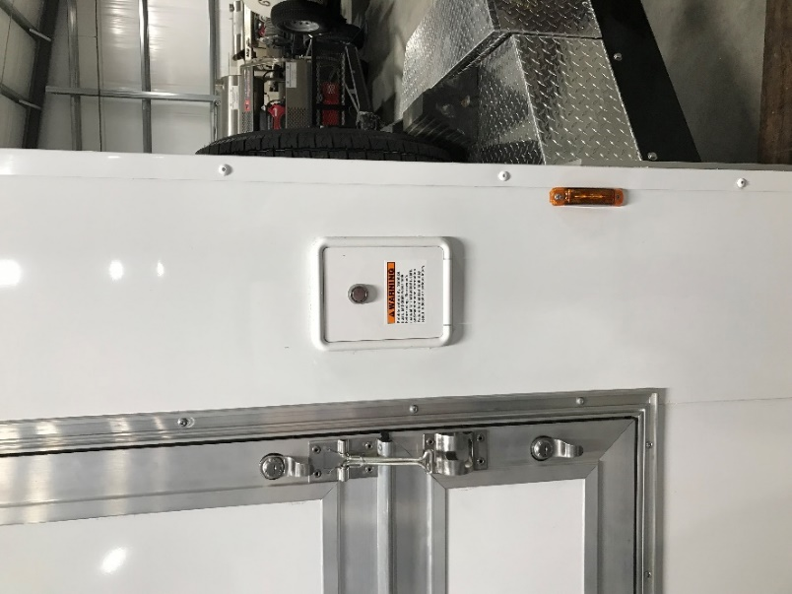

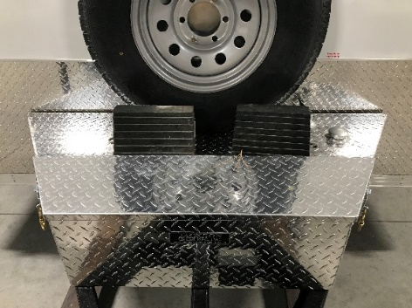**Fuel tank** – fill on-site or close to destination

* 20-gallon capacity
* Located on the front of the trailer under the spare tire
* Fill opening on street side
* Must be NON-ethanol gasoline ONLY. NO EXCEPTIONS.

**Power**

* Ideally, the on-board trailer generator should only be used for 24 hours before switching to external power.
* Generator operations
  + Hook up the exhaust venturi, located on the street side front. Exhaust pipe is directly under the door to the generator. Venturi kit is stored under the lower cages (streetside).
  + Generator is started inside the trailer at the generator switch panel under the sink
  + To start – hold switch down to the prime position for 5 seconds, release, push switch up to start position, hold and wait for generator to crank
  + Let generator run for 5 minutes before using trailer electricity (the 12-volt lights inside will work on battery power)
  + To turn generator off, press switch down to the stop position

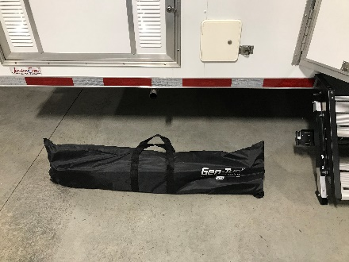 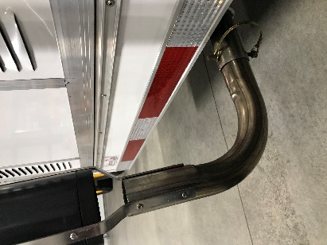 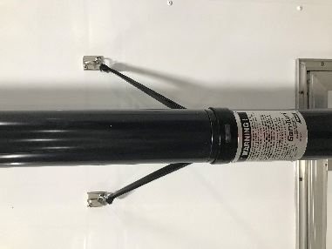 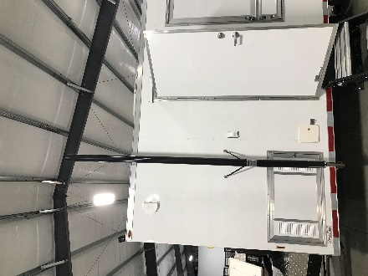

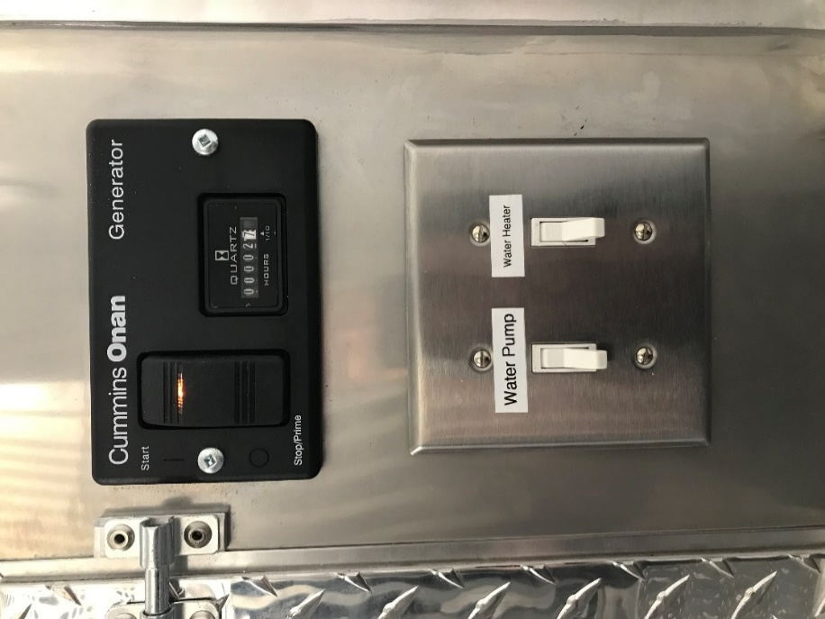

* **Hardwire connection** (Shoreline plugged in)
  + 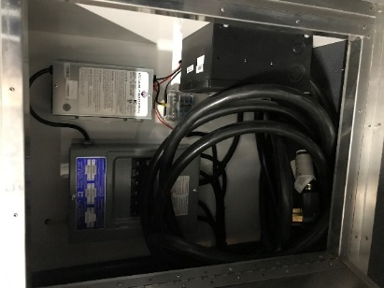Shoreline cable located under the sink, access door on the side
  + 50-amp female plug
  + Turn off generator once plugged in
* **Breaker panel** located under the sink, inside the side door where the Shoreline cord is
* 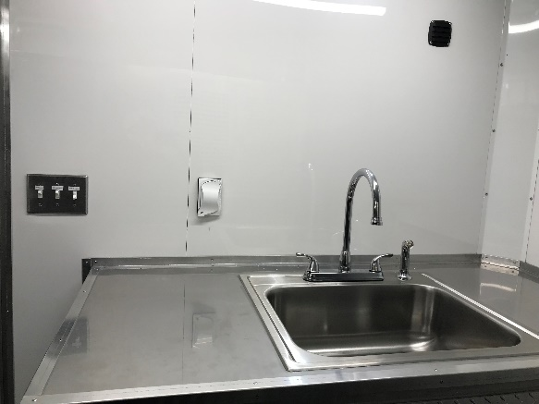**Lights**
  + Light switch is just inside the side door
  + 12-volt lights work without generator/hardwire

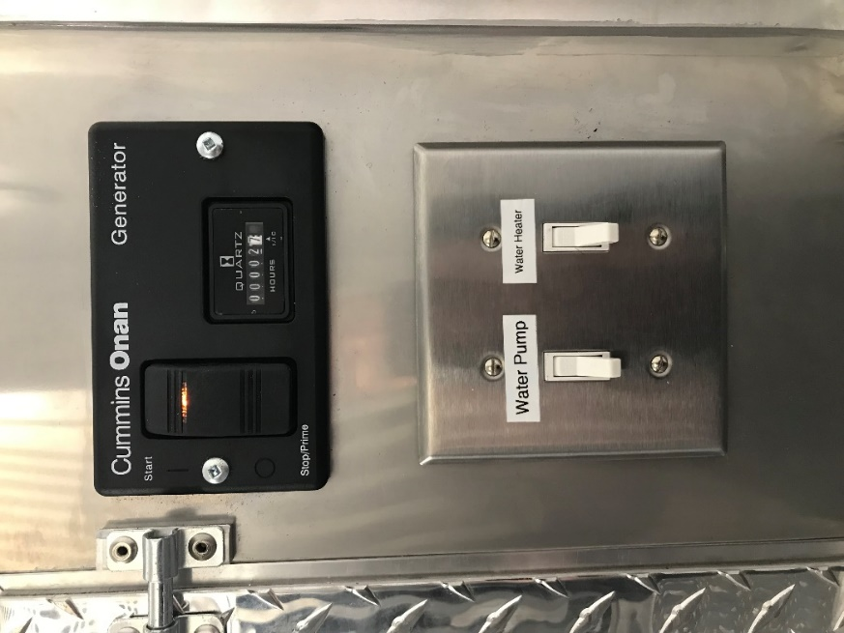

* **Water heater**
  + Turn on left handle of faucet (hot water)
  + Turn water pump switch on (under the generator switch panel)
  + Once water is coming out of the faucet, turn the hot water handle off
  + Turn water heater switch on
  + Leave water pump and water heater on for duration of trailer operations

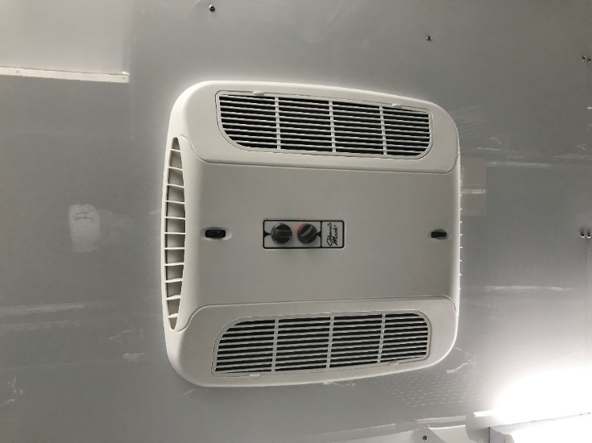**HVAC – Heating, Ventilation, Air Conditioning**

* Two (2) 13.5 BTU AC Units with 5.5 BTU Heat, Roof Mounted
  + Must be using generator or hardwire power
  + Adjust thermostat knob to desired temperature
  + Adjust fan speed

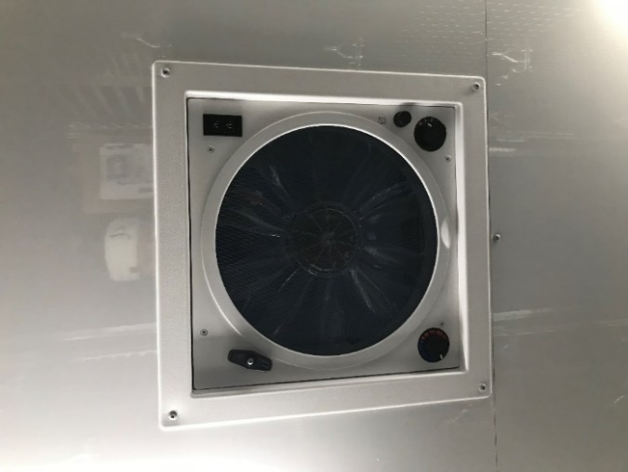

* Two (2) 12-Volt Roof Exhaust Fans
  + Open fans with black turn handle
  + Turn numbered knob to desired fan speed
  + Press black switch for exhaust out or air intake
  + Leave closed if not in use

**Wastewater tank**

* 35-gallon capacity
* Emptying the wastewater tank
  + Option 1: Run a sewer connection from the trailer to an appropriate sewer system (NOT a storm drain)
    - Trailer sewage drain (black) is located to the right of the side door steps
    - Hose is a trip hazard – place cones or similar around it to make workers aware
  + Option 2: Hook up septic truck to system and drain every 24 hours
  + How often you empty the wastewater tank is highly dependent on the number of animals you are housing and the waste that is generated by cleaning

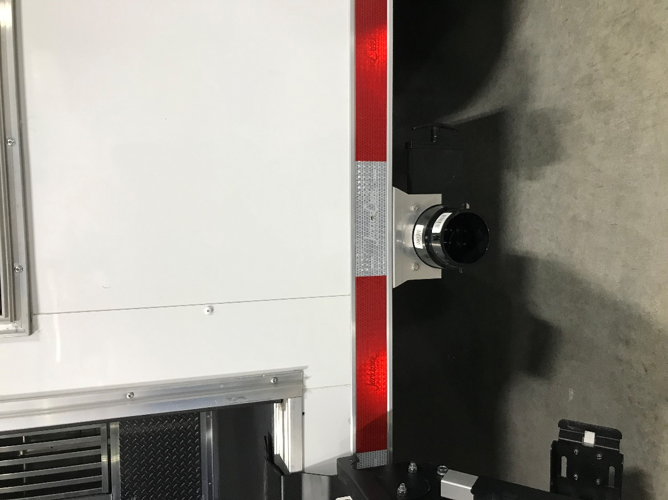

**Cleaning inside the trailer using the hose**

* Hose hook up is located on the side of the sink (white “spray port”)
* Entire interior of the trailer can be sprayed out if no animals present
* Clean as much large debris (ex. cat litter) out of the cages as possible manually to reduce the chance of the drains clogging
* Spray towards the drains at the back of the cages – they empty into larger drain pipes
* Larger drain pipes that go to the wastewater tank are located at cages U5/L4, U10/L8, U19/L15
  + Insert hose into drain at U1/L1 🡪 cleans drain for U1-4/L1-3 🡪 drain to pipe at U5/L4
  + Insert hose into drain at U6/L5 🡪 cleans drain for U5-10/L4-8🡪 drain to pipe at U10/L8

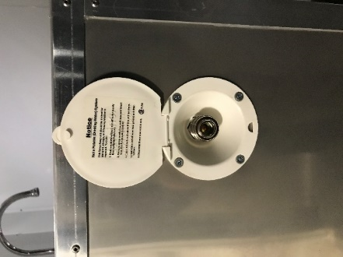 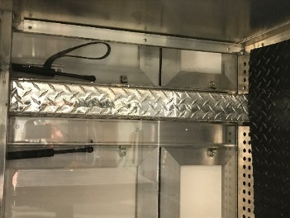 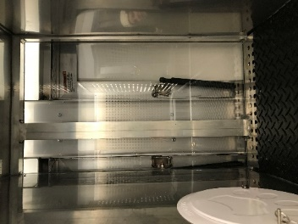

**Back ramp door**

* Do not leave locks on when the trailer is occupied/in-use
* Whenever ramp door is down, place pool noodles on cables for safety

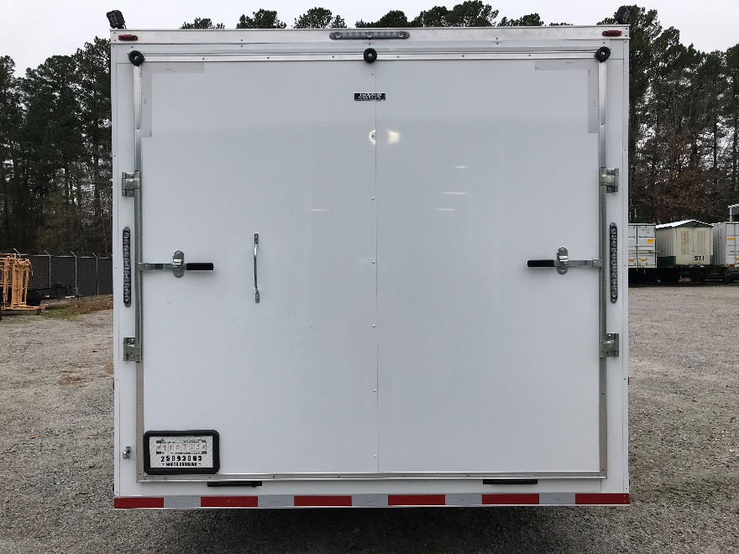 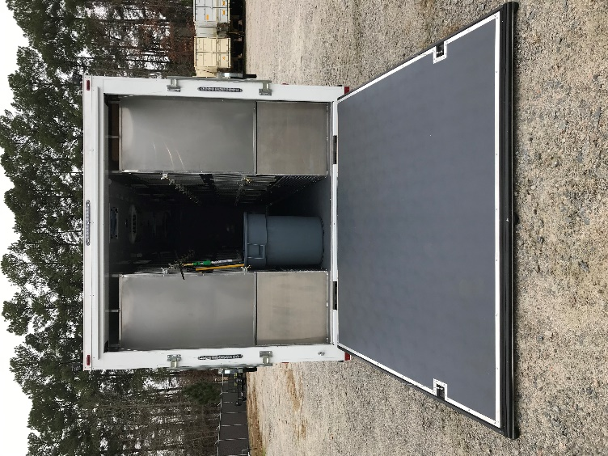

**Opening the side awning doors** (optional)

* All 4 locks must be unlocked on each door (small silver keys)
* The door will swing up as a one-piece unit
* Alternatively, you can open the lower portion and hook at 90 degrees, then raise the awning
* Once awning doors are in the raised position, locks must be placed on arms for safety (located under the sink)

