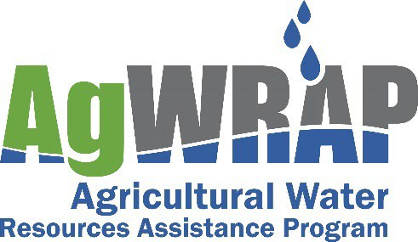
Background

Fiscal Year 2027 Detailed Implementation Plan July 29, 2026

The North Carolina Agricultural Water Resources Assistance Program was authorized through Session Law 2011‐145 and became effective on July 1, 2011. This program, herein referred to as AgWRAP, was established to assist farmers and landowners in doing any one or more of the following:
- Identify opportunities to increase water use efficiency, availability, and storage;
- Implement best management practices (BMPs) to conserve and protect water resources;
- Increase water use efficiency;
- Increase water storage and availability for agricultural purposes.

AgWRAP is administered by the North Carolina Soil and Water Conservation Commission and implemented through local soil and water conservation districts. The commission meets with stakeholders to gather input on AgWRAP’s development and administration through the AgWRAP Review Committee. AgWRAP currently receives $977,500 in recurring state appropriations: $817,500 is available for BMP allocation, while remaining funding is used to support two division engineering positions.

Fiscal Year 2027 Annual Goals

- Conduct a competitive regional allocation process for selected AgWRAP BMPs.
  - Fund projects in each of the division’s regions: western, central, and eastern.

- Allocate funds to soil and water conservation districts for all AgWRAP BMPs.
  - Award funds to all districts requesting an allocation.
  - Allocate funds to districts from all geographic areas of the state.

- Conduct training for districts.
  - Continue to train districts on the program.
  - Provide technical training for the required skills to plan and implement approved AgWRAP BMPs.
  - Maintain the AgWRAP website with all relevant information.

Fiscal Year 2027 Allocation Strategy

Due to the high cost of some of the program’s eligible best management practices, and the limited funding for the program, the Commission will award two allocations for AgWRAP.

Competitive regional application process for selected AgWRAP conservation practices: 20% of available BMP funding.
The Commission will allocate FY2027 funding through a competitive regional application process for
following program practices:
  - Agricultural water supply/reuse pond
  - Agricultural pond repair/retrofit
  - Agricultural water storage and/or collection system
  - Conservation irrigation conversion

The regions, as depicted in Figure 1, are eligible to receive 1/3 of the amount of funds in the regional pool. Applications will be approved using the same ranking criteria for each region; a minimum score for funding will be determined by the committee. The highest ranking applications per region will move on to the site assessment phase of the application process. Should a region not have sufficient applications to fund, the commission will allocate the remaining funds by approving applications in other regions, funding applications by highest score. Should the regional pool not have enough highly ranked applications to encumber available funding, the remaining funds (AP) will be allocated through district allocations (AG) via the supplemental allocation process described on page 4.

Figure 1: Regions for AgWRAP allocations
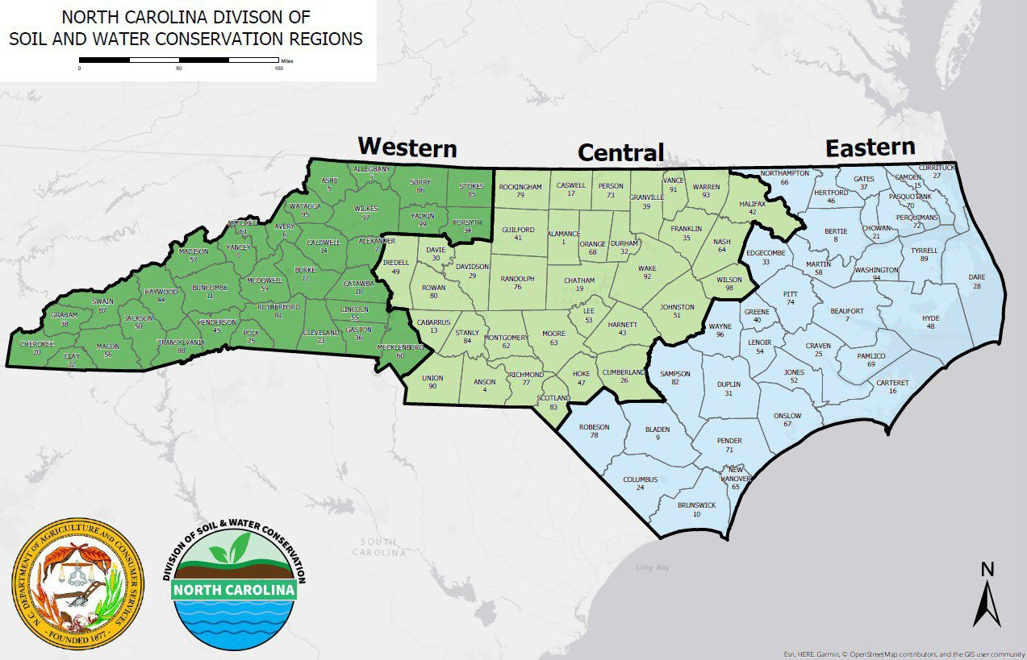

District allocations: 80% of available BMP funding.
- Allocations will be made to all districts requesting funds in their FY2027 Strategic Plan.
- Allocation parameters are described in 02NCAC 59D .0105 Agricultural Water Resources Assistance Program Financial Assistance Allocation Guidelines and Procedures.
Table 1: Allocation Parameters

Parameter | Percent
Relative rank of the number of farms (total operations) that are in the respective district as reported in the Census of Agriculture. | 20%
Relative rank of the total acres of land in farms that are in the respective district as reported in the Census of Agriculture. | 20%
Relative rank of the Market Value of Sales that are in the respective district as reported in the Census of Agriculture. | 15%
Relative rank of the amount of agricultural water use in the respective district as  reported in the North Carolina Agricultural Water Use Survey. Data from the most recent three surveys will be averaged to determine each district's rank. | 25%
Relative rank of population density as reported by the state demographer. | 20%

Conservation plan requirement

All approved AgWRAP applications must have a complete conservation plan prior to contract approval or the district requesting design assistance from division engineering staff. The commission is requiring this plan, which is the cooperator’s record of decisions, to help districts evaluate water supply resource concerns including inadequate water for livestock, inefficient water use for irrigation, and/or inefficient moisture management. Conservation plans will ensure that alternative practices are considered and that the recommended practices address the identified resource concerns to maintain AgWRAP BMPs throughout their contract life.

Program Guidelines
AgWRAP will be implemented using rule 02 NCAC 59D.

The agricultural water definition, from Protecting Agriculture Water Resources in North Carolina Strategic Plan (February 2011) will be used to determine eligibility for AgWRAP.

Agricultural water is considered to be any water on farms, from surface or subsurface sources, that is used in the production, maintenance, protection or on‐farm preparation or treatment of agriculture commodities or products as necessary to grow and/or prepare them for on‐farm use or transfer into any form of trade as is normally done with agricultural plant or animal commerce. This expressly includes any on‐farm cleaning or processing to make the agricultural product ready for sale or other transfer to any consumer in a usable form. It does not include water used in the manufacture or extended processing of plants or animals or their products when the processor is not the grower or producer and/or is beyond the first handler of the farm product.

All eligible operations must have been in existence for more than one year, and expansions to existing operations are eligible for the program.

The percent cost share for all BMPs is 75%. Limited resource, beginning farmers, and farmers enrolled in Enhanced Voluntary Agriculture Districts are eligible to receive 90% cost share. The contract maintenance period of most practices is 10 years.

For Water Supply Well contracts, if there are additional water sources under the cooperator’s control, the contract must explain why these sources are inadequate to meet the operation’s needs.

AgWRAP components cannot be combined with ACSP or CCAP components in the same contract. Cooperators cannot submit multiple AgWRAP applications within the same year. Applications can be submitted in subsequent years, but only if all existing AgWRAP contracts are 100% complete.

Soil and water conservation districts can adopt additional guidelines for the program as they implement AgWRAP locally.

District Supplemental Allocation Process
Districts may voluntarily return AgWRAP allocations at any time during the fiscal year. These returns, along with any unallocated AP funds, may be re-allocated to the general (AG) fund.

At the beginning of February of each fiscal year, districts may request additional funds for supplemental, new, and repair contracts through an online application process. Initial requests will close at the end of February, and allocations will begin in early March. All requests will be sorted by district, submission date and time, and contract type. Supplemental and repair contracts take priority over new contracts.. Once each district receives funding for one contract, the process repeats with each district receiving funds for their second priority contract based on submission date and time until funds are exhausted or early June.

BEST MANAGEMENT PRACTICES ELIGIBLE FOR COST SHARE PAYMENTS

- The best management practices eligible for cost sharing include the practices listed in Table 2 and any approved District BMPs.
  - District BMPs shall be reviewed by the Division for technical merit in achieving the goals of this program. Upon approval by the Division, the District BMPs will be eligible to receive cost share funding as described in 02 NCAC 59D .0106.

- The minimum life expectancy of the BMPs shall be listed in Table 2. Practices designated by a District shall meet the life expectancy requirement established by the Division for that District BMP.

- The list of BMPs eligible for cost sharing may be revised by the Soil and Water Conservation Commission as deemed appropriate to meet the program purpose and goals. Additional practices may be adopted and introduced during the program year.

Table 2. Best management practices eligible for cost sharing, the minimum life expectancy of each practice, and the practice type.

PRACTICE | MINIMUM LIFE EXPECTANCY (years) | PRACTICE TYPE
Agricultural water supply/reuse pond | 10 | DESIGN
Agricultural pond repair/retrofit | 10 | DESIGN
Agricultural pond sediment removal | 1 | DESIGN
Agricultural water storage and/or collection system | 10 | DESIGN
Baseflow interceptor (streamside pickup) | 10 | DESIGN
Conservation irrigation conversion | 10 | DESIGN
Water supply well | 10 | DESIGN
Livestock water storage | 10 | DESIGN

- Agricultural water supply/reuse pond: Construct agricultural ponds for water supply for irrigation or livestock watering. Benefits may include water supply, erosion control, flood control, and sediment and nutrient reductions from farm fields.

- Agricultural pond repair/retrofit: Repair or retrofit of existing agricultural pond systems. Benefits may include water supply, erosion control, flood control, and sediment and nutrient reductions from farm fields.

- Agricultural pond sediment removal: Remove sediment from existing agricultural ponds to increase water storage capacity. Benefits may include water supply, erosion control, flood control, and sediment and nutrient reductions from farm fields. Cooperators are ineligible to reapply for assistance for this practice for a period of 10 years; unless the sedimentation is occurring due to no fault of the cooperator.

- Agricultural water storage and/or collection system: Construct an agricultural water management and/or collection system for water reuse or irrigation for agricultural operations. These systems may include any of the following: water storage tanks, pumps, water control structures, and/or water conveyances. Benefits may include reduced demand on the water supply by reuse and decrease withdrawal from existing water supplies.

- Baseflow interceptor (streamside pickup): Improve springs and seeps alongside a stream, near the banks, but not in the channel by excavating, cleaning, capping to collect and/or store water for agricultural use. Benefits may include water supply, erosion control, and flood control.

- Conservation irrigation conversion: Modify an existing irrigation system to increase the efficiency and uniformity of irrigation water application. Benefits include increased water efficiency and water availability, erosion control, and produce safety.

- Water supply well: Construct a drilled, driven, or dug well to supply water from an underground source for irrigation, livestock and poultry, aquaculture, or on‐farm processing.

- Livestock water storage: Construct a system of water storage for the purpose of watering livestock. These systems may include any of the following: construction of impoundments, water storage tanks, pumps, and/or water conveyances. This practice can accompany a water collection/supply BMP to allow for additional pumping and water storage. Benefits may include increased water storage.

