Review of Establishment Data Task Reference Guide
References
FSIS Directive 5000.2, Review of Establishment Testing Data by Inspection Program Personnel
FSIS Directive 6410.4, Verifying Swine Slaughter Establishments Maintain Adequate Procedures for Preventing Contamination of Carcasses and Parts by Enteric Pathogens
FSIS Directive 10,240.4, Listeria Rule Verification Activities
Review of Establishment Data Task – Inspection Methods Module

Introduction
As per an AskFSIS question posted in Attachment 1 of this document, the intent of FSIS Directive 5000.2 is to clarify that IPP have access to all establishment records that impact the establishment’s hazard analysis.
Establishments may conduct certain testing or monitoring activities that are not a part of their HACCP plans or SSOPs. For example, establishments may perform testing or monitoring activities as part of a program or conduct product testing to comply with certain specifications of their customers (e.g., big box stores via third party auditors). Data generated by such activities may not even be referenced in a hazard analysis. Nonetheless, these activities may provide information relevant to effectiveness of the establishment’s food safety systems; the data may raise questions or concerns about the adequacy of the establishment’s hazard analysis.
The results of any testing that is performed by the establishment that may have an impact on the establishment’s hazard analysis, whether or not such testing is incorporated into an actual HACCP plan, referenced in a hazard analysis, or considered in assessing a prerequisite program, are subject to FSIS review and must be made available to FSIS personnel.
Remember: IPP have the authority to access all establishment records that could disclose the existence of insanitary conditions (9 CFR 320.6).
Performance of the Review of Establishment Data Task
At least once per week, IPP should schedule and perform the PHIS Review of Establishment Data task. IPP should review the results of any testing that the establishment has performed that may have an impact on the hazard analysis.
The purpose of this task is generally to verify any testing the establishment performs outside of their food safety systems (i.e., not included as support in their HACCP system or SSOPs) that could have an impact on decisions made in their hazard analysis, however, over time and with updates made to directives the purpose of this task has been made a little broader.
Examples of records/programs reviewed under the Review of Establishment Data Task:
- An establishment performs post-sanitation swabbing for allergen residues of food contact surfaces (FCS) for which products containing allergens contact. The swabbing, with negative results, shows that establishment sanitation procedures are effective in the removal of allergen residues. The swabbing, with positive results, shows that establishment sanitation procedures are not effective in the removal of allergen residues. This testing is not a regulatory requirement by FSIS, however, it is required by the establishment’s third-party auditor. The establishment does not include this testing in conjunction with their allergen program as part of their HACCP system. However, the results of this testing could impact the hazard analysis, and therefore, inspection personnel must have access to these records.

- An establishment performs post-sanitation swabbing of food contact surfaces (FCS) for the presence of APC (Aerobic Plant Count) bacteria. The purpose of the swabbing is to ensure the establishment’s sanitation procedures are effective in reducing the presence of APC bacterial cells on FCS. This testing is not a regulatory requirement by FSIS, however, the establishment does it to ensure their sanitation procedures remain effective by implementing a Pass or Fail parameter. If the FCS fails, the establishment implements additional cleaning procedures as part of the program prior to the start of operations. The establishment does not include this testing as part of their HACCP system or SSOPs. However, the results of this testing could impact the hazard analysis, and therefore, inspection personnel must have access to these records.

- An RTE establishment tests their water supply which is used as an ingredient in products and for sanitation purposes, for the presence of Listeria spp. The establishment receives positive or negative results from the laboratory, but the specific species is not reported. This testing is not a regulatory requirement by FSIS, however, it is required by the establishment’s third-party auditor. The establishment does not include this testing in conjunction with their Listeria program as part of their HACCP system. However, the results of this testing could impact the hazard analysis, and therefore, inspection personnel must have access to these records. You should discuss with your supervisor concerns regarding the positive test results and the laboratory not reporting the actual species of Listeria found.

- Some establishments may include metal detection in their process to meet a customer specification. The establishment’s hazard analysis may reference preventive maintenance programs and visual checks for metal contamination as support for metal being NRLTO but not include the customer-required metal detection program (i.e., running a specified amount of product for the customer through a metal detector) as additional support. Nonetheless, the metal detection program has implications for food safety, and the records associated with the metal detection program should be made available to IPP for review.

- As per FSIS Directive 6410.4, Verifying Swine Slaughter Establishments Maintain Adequate Procedures for Preventing Contamination of Carcasses and Parts by Enteric Pathogens, IPP are to review establishment microbiological sampling records (during the Review of Establishment Data task) as instructed in FSIS Directive 5000.2, Review of Establishment Testing Data by Inspection Program Personnel to verify that the establishment collects and analyzes microbiological samples as described in its written sampling plan and at the required locations and frequencies per 9 CFR 310.18(c).

- As per FSIS Directive 10,240.4, Listeria Rule Verification Activities, during subsequent weekly meetings, as described in FSIS Directive 5000.1 and FSIS Directive 5000.2, Review of Establishment Testing Data by Inspection Program Personnel, IPP are to discuss the following:
- Results from establishment sampling and any corrective actions the establishment took in response to positive results;
- Results of any FSIS sampling that was recently performed and notify the establishment when they will be collecting samples following the instructions in FSIS Directive 10,240.3, FSIS Ready-to-Eat Sampling Programs; and
- Instances when establishments change practices as further described in FSIS Directive 10,240.3, FSIS Ready-to-Eat Sampling Programs Chapter III, Section II. D.3.
NOTE: If an establishment does not perform any testing outside of its food safety system or does not have to meet the requirements of FSIS Directive 6410.4 or FSIS Directive 10,240.4 the task can be removed from the task list in PHIS and therefore not performed. Other testing/programs incorporated into an establishment’s SSOP or HACCP system should be verified during the appropriate SSOP or HACCP task; it would not be necessary to review these records again during a Review of Establishment Data task, unless a directive specifies otherwise.
For example, an establishment incorporated all parts of their metal detection program, including calibration of the equipment and the testing of products as part of their HACCP system in support of a metal hazard being NRLTO. The program and records would be reviewed under the applicable HACCP verification tasks, not under the Review of Est. Data task.

Documenting the Results of Records Reviewed under Review of Establishment Data Task in the Weekly Meeting MOI
Inspection program personnel are to document each week in the weekly meeting as described in FSIS Directive 5000.1, Verifying an Establishment’s Food Safety System, and 5010.1, Food Safety Related Topics for Discussion during Weekly Meetings with Establishment Management, that they conducted the records review, and that they discussed, if indicated, any concerns with the establishment at the weekly meeting. When utilizing the established Weekly Meeting Template by the MPID Training Team, such discussion should be documented under “#3: Plant testing data to be reviewed per FSIS Directive 5000.2.” The following would be included as part of that discussion:
1. briefly list what test results they reviewed and for what time period,
2. describe the specific concerns, if any, that they discussed with the establishment and
3. state how the establishment responded.
If you have questions or concerns, contact your Area Supervisor.

Regulations to Verify and Select within the Review of Establishment Data Task
While conducting the Review of Establishment Data task and reviewing the:
- Listeria results from the establishment sampling of Food Contact Surfaces (FCS) to meet requirements with the Listeria Rule as per 9 CFR 430 and FSIS Directive 10,240.4 you will verify and select the following regulations within the task:
  - 9 CFR 320.6
  - 9 CFR 417.5(a)(1)
  - 9 CFR 417.5(f)
NOTE: The 9 CFR 430 (Listeria Rule) regulations are not available for selection in the Review of Establishment Data task, even though the results are reviewed and documented in the Weekly Meeting MOI as part of the task. You will verify compliance with all aspects of the Listeria Rule, including the sampling results (again), during the applicable SSOP or HACCP Verification task (depending on which program the establishment has included their sampling program in).
- For establishments that only slaughter swine or those that slaughter swine in the greatest number and therefore perform their sanitation indicator sampling as per 9 CFR 310.18(c) and FSIS Directive 6410.4 on swine, you will verify and select the following regulations within the task:
  - 9 CFR 320.6
  - 9 CFR 310.18(c) to ensure the establishment collects and analyzes samples as described in its program and at the required locations and frequencies. Any additional requirements as stated in 9 CFR 310.18(c) and 310.18(d) will be verified during the applicable HACCP or SSOP task as discussed in FSIS Directive 6410.4.
  - If the establishment includes the sampling program in:
    - A HACCP plan you will also verify and select:
      - 9 CFR 417.5(a)(1) and
      - 9 CFR 417.5(f)
    - The SSOP you will also verify and select:
      - 9 CFR 416.16(a) and (c)
NOTE: If the establishment has a waiver or letter from FSIS allowing for different sampling locations or an alternative frequency for sampling, you will also verify the establishment is following the parameters in that waiver or letter as per 9 CFR 303.1(h). Waivers and Letters can be viewed in the Establishment Profile via the Facility page and Waivers & Letters tab.
- For establishments conducting testing or activities not incorporated in the food safety system (HACCP or SSOP) as support, but it has been determined that the testing or activities could have an impact on the hazard analysis, you will verify and select the following regulations within the task:
  - 9 CFR 320.6
  - 9 CFR 417.5(a)(1)
  - 9 CFR 417.5(f)
Once IPP have reviewed the necessary documentation, discussed any concerns with establishment management, and included the discussion in the weekly meeting MOI, they are to select the regulations verified and mark the Review of Establishment Data task as complete in PHIS.

Refusal of Access to Records
If an establishment refuses access to records for which the IPP believes are subject to review because they could impact the hazard analysis or if IPP are uncertain as to whether a record should be reviewed, discuss this with your supervisor.
If an establishment refuses to provide access to its HACCP plan or other supporting documentation for review and recording of information into PHIS, IPP are to:
- Document a noncompliance citing 9 CFR 417.5(f),
- Discuss the noncompliance with establishment management and document the discussion and response in the weekly meeting MOI and
- Contact your supervisor.

Revised: 2/26/2026

Attachment 1: AskFSIS Question Clarifying the Purpose of FSIS Directive 5000.2
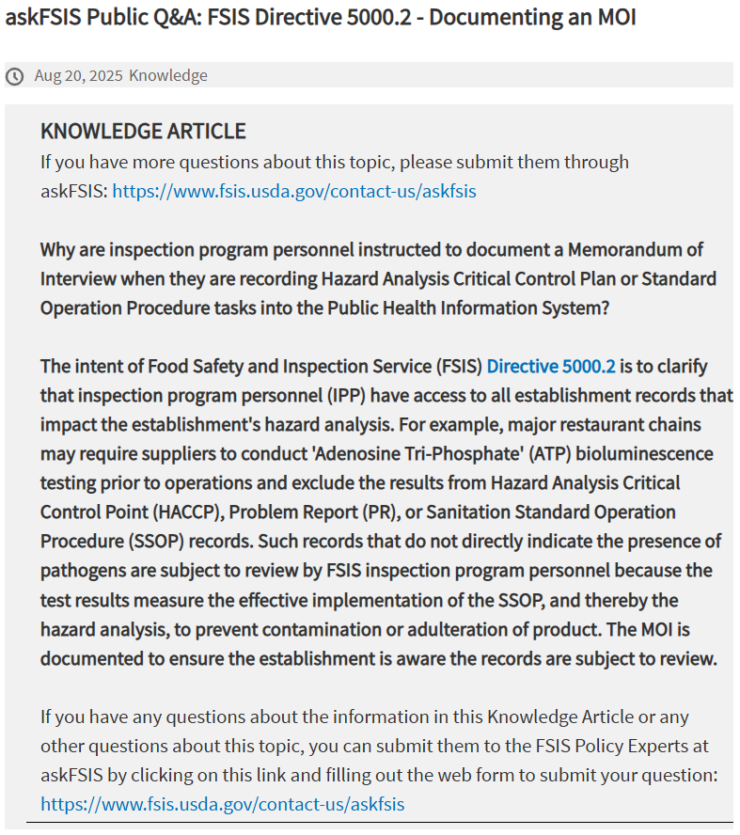
FSIS Directive 5000.2 - Documenting an MOI

Attachment 2: Frequently Asked Questions
- While conducting the Review of Establishment Data task and reviewing the documentation from establishment testing or activities not incorporated in the food safety system (HACCP or SSOP), would issues with the activities be documented in a noncompliance record?
-The answer is generally, no, unless you are otherwise instructed. We would have to be able to prove that insanitary conditions exist based on the results and subsequent lack of actions taken by an establishment to document noncompliance. This would be something that would need to be run up the chain of command to your supervisor, then the T/A Coordinator, etc. prior to noncompliance being documented.
-Issues and concerns should be discussed and documented in the weekly meeting MOI and discussed with your supervisor.
-Weekly meeting documentation is considered, along with NRs, in making further enforcement decisions in establishments.
- When would an inspector copy documents as per 9 CFR 417.5(f)?

The answer is that unless you are instructed by your Area Supervisor or T/A Coordinator to copy documents you should not do so.

A couple instances where copying of documentation may be requested of you is if 1) the establishment is in the midst of a recall or 2) it is being considered whether further enforcement action (such as a suspension) is going to be taken on the establishment by the agency and documentation is needed to support the decision.

