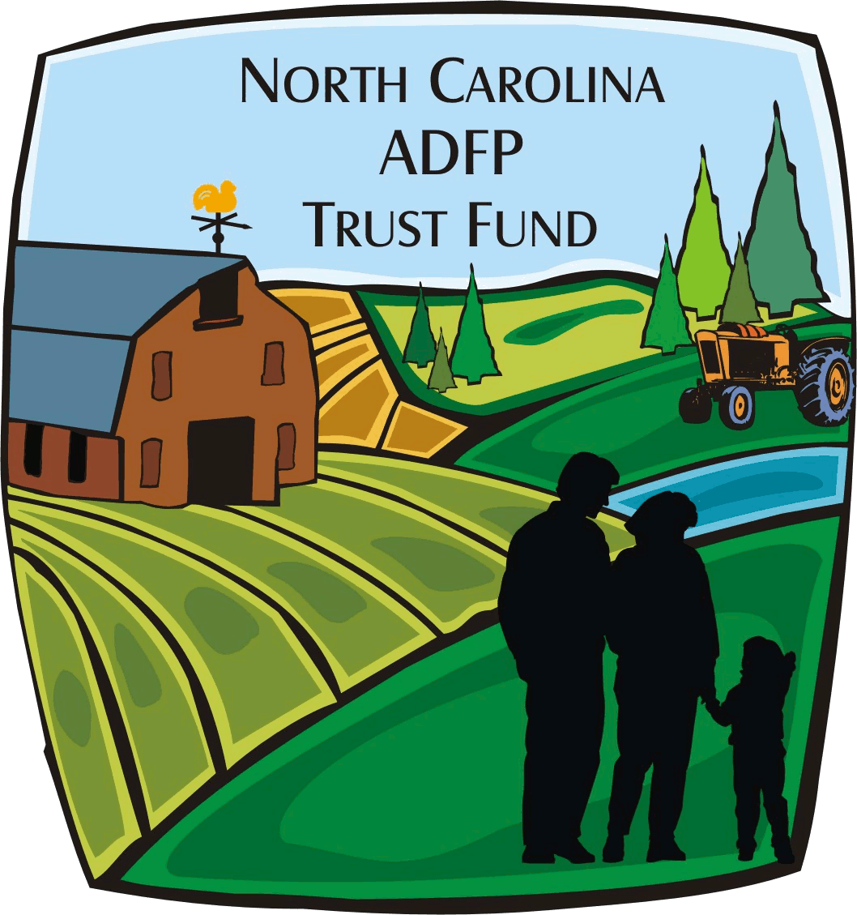
N.C. Department of Agriculture & Consumer Services
N.C. ADFP Trust Fund
Conservation Easement Closing Check Request

Project Information
ADFP Tracking Number: ADM-ADFP- - | Date of Report:
Grantee:
Project Title:
Tax ID Number: | Project Start & End Dates: to
Contract Number:

The following list of items must be submitted and approved within 150 days of the beginning date of the grant contract:
 |  | Grantee Initials | ADFPTF Initials
 | Signed and notarized Easement Restriction Acknowledgement form
 | Preliminary Conservation Easement Survey, including GIS, per the ADFPTF Survey Requirements and Checklist
 | Preliminary Title Commitment
 | Preliminary Attorney’s signed Title Opinion certifying title for a period of at least sixty years

The following list of items must be submitted and approved within 180 days of the beginning date of the grant contract:
 |  | Grantee Initials | ADFPTF Initials
 | Certified Development Rights Appraisal dated less than 1 year prior to closing

The following list of items must be submitted and approved within 210 days of the beginning date of the grant contract and no less than 60 days before the scheduled conservation easement recording date:

 |  | Grantee Initials | ADFPTF Initials
 | Environmental Audit including Hazardous Materials Checklist and Landowner Interview
 | Conservation Plan, if applicable
 | Forestry Plan, if applicable
 | Preliminary Baseline that includes applicable Conservation Plan and Forestry Plan, Environmental Audit, and Conservation Easement Survey, per the ADFPTF Baseline Documentation Report Requirements and Checklist

The following list of items must be submitted and approved within 240 days of the beginning date of the grant contract and no less than 30 days before the scheduled conservation easement recording date:

 |  | Grantee Initials | ADFPTF Initials
 | Final Conservation Easement Survey in recordable format
 | Final Conservation Easement with applicable exhibits
 | Final Title Commitment approved by NCDA
 | Signed Subordination Agreement, if applicable

The following list of items must be submitted and approved within 270 days of the beginning date of the grant contract and no less than 30 days before the scheduled conservation easement recording date:

 |  | Grantee Initials | ADFPTF Initials
 | Preliminary HUD Statement
 | Up-to-date Budget/Progress Reports
 | Updated Signature Card, W-9, and Vendor Electronic Payment Form if last update was more than one year prior

If all documents are submitted and approved, the conservation easement closing payment request may be submitted in writing by the Grantee 30 days before the proposed closing date using this form.

This form must be submitted with the Request for Payment form.

Enter the total Easement Purchase requested from ADFPTF:

Budget Item # | Budget Category | Amount
211 | Easement Purchase | $

Certification: I certify that this information is correct and based on generally accepted accounting standards and principles. The above expenditures are based on actually payments of record for the purpose of and in accordance with the terms of the grant contract. The funds requested are for the conservation easement purchase and do not duplicate a previous request. The documentation will be retained in our files for future audits (Counties should use local government bidding requirements on projects).
Authorized Representative  Name:  Title: | Telephone Number:  E-mail Address:
Signature of Authorized Representative: | Date:

For ADFP Trust Fund Use Only:
Approval by Legal Staff: | Approval by Budget Administrator: | Approval by Division Director:
Date: | Date: | Date:

Notes:

